FORMPAK INC

The IOM covers the following:
- S30/C30
- S45/C45
- S50/C50
- S60/C60
- S80/C80

Flex Screw Conveyor IOM
2021 eDITION

DISCLAIMERS:

NOT ALL ITEMS IN THIS MANUAL ARE ON EVERY SYSTEM.

SYSTEM CONFIGURATIONS VARY PER CUSTOMER ORDERS & SPECS.

ANY MODIFICATIONS TO THE EQUIPMENT WITHOUT APPROVAL OF FORMPAK ENGINEERING WILL RESULT IN VOIDING ANY WARRANTY.

Operation Hours

Monday – Friday 8:00AM-5:00PM CST

Contacts at FormPak

Mike Owens Ext 402
Sales / General Questions
Email: mike@formpakinc.com

Larry Markos, P.E. Ext 403
Engineering / Technical Support / Maintenance
Email: larry@formpakinc.com

Robert Contreras Ext 405 Operations Manager Email:
Email: robert@formpakinc.com

Joseph Beckerman Ext 414
Electrical / Controls Email:
Email: josephb@formpakinc.com

Brian Beirne Ext 412
Purchasing / Parts Email:
Email: brianb@formpakinc.com

Fax: 314-475-3201

FSC INDEX
Section Page
- Installation 2-6
- Mechanical 2-5
- Electrical 6
- Operation & Explanation 7-10
- Maintenance 11-13
- FormPak Machinery Catalog 14

Installation
- Mechanical
- Flexible Screw Conveyor
FormPak FlexFlo Flexible Screw Conveyor (FSC) Installation:

Inventory Parts: Basic parts of the Flexible Screw Conveyor are the: FSC Pickup, auger tube, auger, auger adapter, Drive Box, gear box, and motor. Refer to the mechanical drawing at the front of this manual. See your mechanical drawing for details.

Layout Position of Infeed and Discharge Head Assembly: In most installations the position of the FSC pickup and outlet are fixed. Once the outlet and inlet are set, the extension tubes from each should line up so that the casing (augur tube) can be trimmed and installed between them. However, they are sometime set to have a “nose over” or “nose under” arrangement, so some flex will be required of the auger tube. It is very important that the auger tube is held “straight” by the T-handle couplings on both ends. Any bend must be along the body of the auger tube, not it’s alignment with mating ends.

Hanging the Drive Box: The Drive Box, Gear Box and Motor are a single assembly (called a Discharge Head) that must be supported by attaching to the Gear Box Mounting Plate to something overhead (joist, ceiling strut, frame, etc.). (Caution! When installing this assembly - it is a heavy awkward load.). There are several mounting holes in the plate to attach chains, cables or steel rods. Assume a 1,000-pound load to size the mounts and supports.
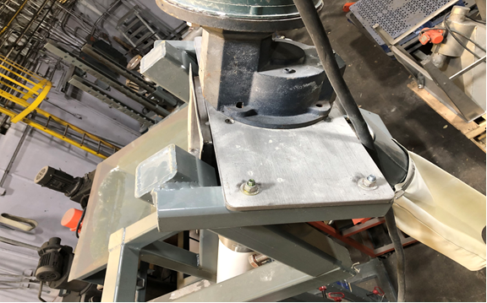
Mounting holes. Bolts in this case, but chains, threaded rods, or cables from above are often used.

Installation
- Mechanical
- Flexible Screw Conveyor (cont.)

Cut the Auger Tube to Length: The auger tube and auger are both sent too long, and must be cut to the proper length on site. We recommend attaching the auger tube to the drive box first. This will help control the off center weight while measuring and cutting the auger tube. Hold the auger tube next to the FSC pick up, and mark the cut line. Once cut, slide the other T Coupling onto the auger tube and tighten. It is critical the that transition into the FSC pick up goes straight in and is not ‘cocked’ at an angle.

Install the Auger – Standard J-Bolt Design: The cap on the infeed should be removed (two clips), and the augur is then fed up the tube to the Drive Box. The access panel on the Drive Box is removed and the augur is pulled over the shaft end to the shoulder (end of shaft) of the auger adapter. There are (2) holes pre-drilled in the shaft that allow J-bolts (shipped separately) to secure the augur. These hook over the auger and tighten it to the shaft. Be sure to use the nuts with nylon inserts. These nuts should not be reused.

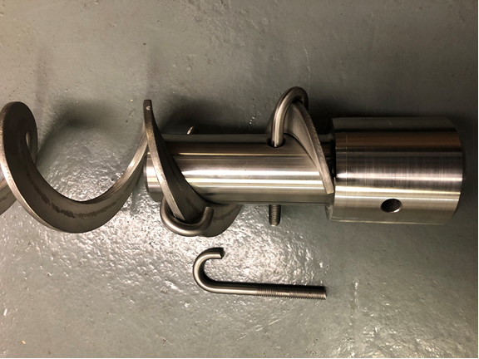

Installation
- Mechanical
- Flexible Screw Conveyor (cont.)

Install the Auger – CleanFlo Design: Flexible Screw Conveyors with the Clean-Flo option have the auger welded to the auger adapter, to minimize areas to be cleaned around the auger. The auger and auger adapter must be pushed up into the auger tube through the FSC pick up. Depending on the clearance between the floor and the FSC pick up, the FSC pick up may need to have the bolts removed, so it can be lifted for more clearance. The auger adapter just slips onto the shaft. There is a single grade 8 bolt that holds the auger adapter to the gear box shaft. Be sure to practice this connection on the ground prior to mounting these parts. If they don’t slide together easily, you will struggle later.

Cut the Auger to the Correct Length: Like the auger tube, the auger is also sent too long, so it can be cut to the correct length in the field. Once the auger adapter is bolted in place, the auger can be cut. There is always some initial stretch with an FSC. It must be cut off so there is about 3” of clearance so it does not rub the white plastic end cap. The best way to do this is to use a pry bar, to pry it out, and cut it off with a Sawzall. After running for an hour or so, remove the end cap. If this white cap is scratched, from the auger, more must be cut off. Severe rubbing can stall the auger.

Avoid running the FSC with no material. It will be noisy, and running empty will shorten the life of the auger tube.

Installation

II.) Electrical
A qualified electrician must install the control panel. Three phase power, 230v or 460v, must be supplied to the control panel for the gyrator and/or other components (conveyor, feeder, valve, etc.) in most cases. Wire between components and to your source is not typically included.

Control panel installation:
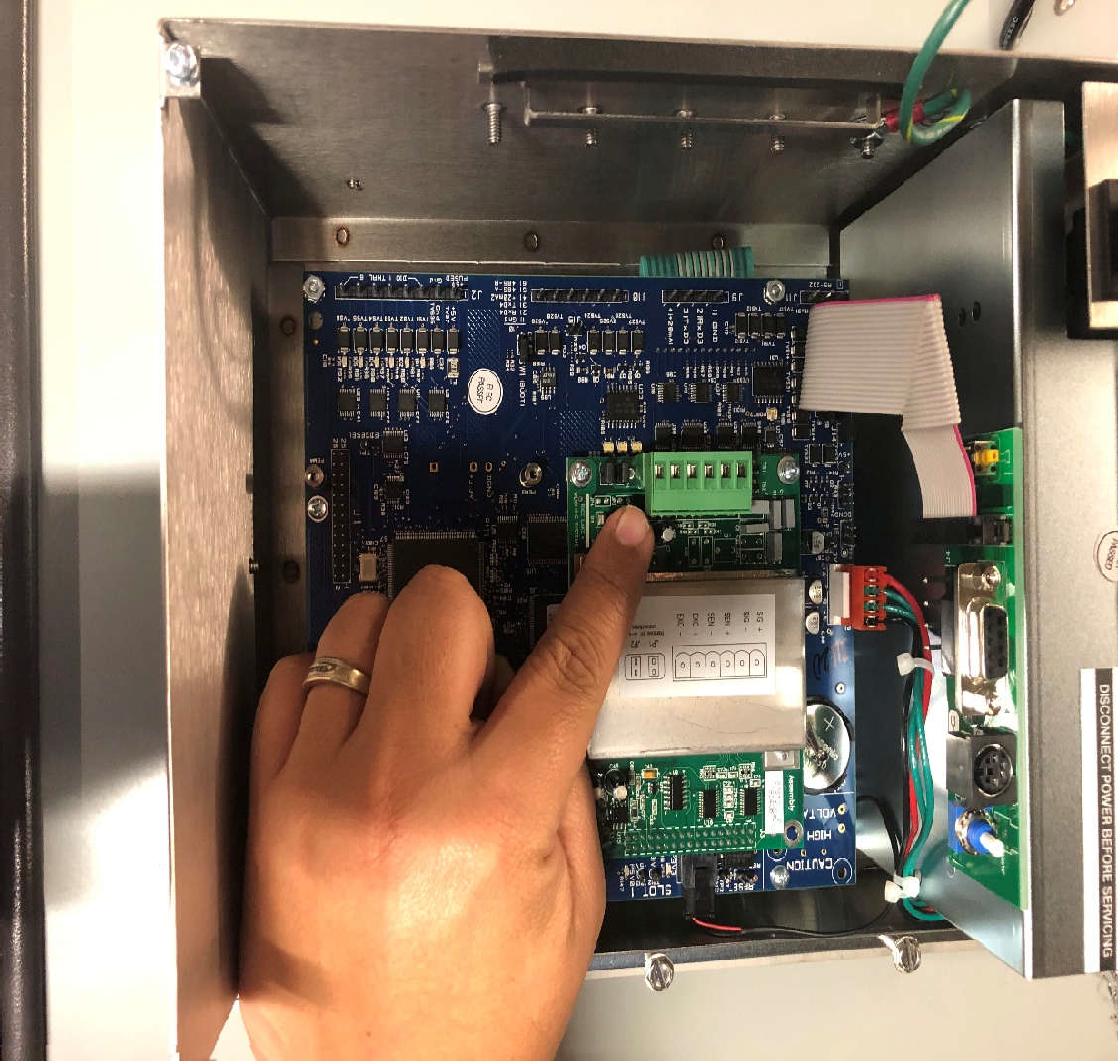
Overview: The control panel will require 460-480 volts three phase power Service amps required. Internally, that will be converted to 24vdc control voltage and 120vac power for the scale controller.

Polarity on the connection from the summing box to the controller is critical. There are plus and minus excitation wires, and plus and minus signal wires, as well as the ground. These wires need to run to the back of the scale controller.

Refer to the Electrical drawing for the motor starter numbers. The VFD is connected to the Flexible Screw conveyor (M2). Direction of rotation of the Rotary Valve, the Blower, and the VFD is critical. Be sure those rotations are correct. The Gyrator can run either direction.

The parameters on the VFD have been preset, but they are on the electrical drawing if required.
Operation
- Flex Screw Conveyor (Cont.)

Flex Screw Conveyor

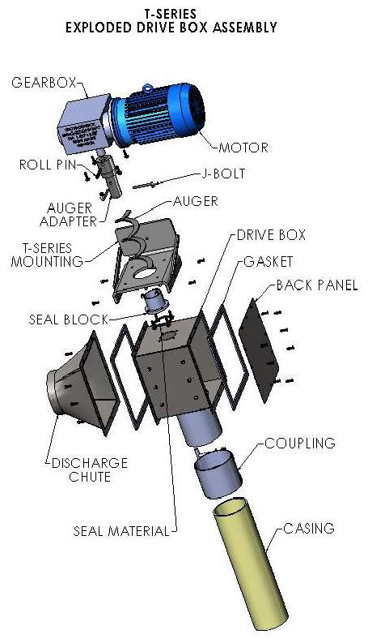
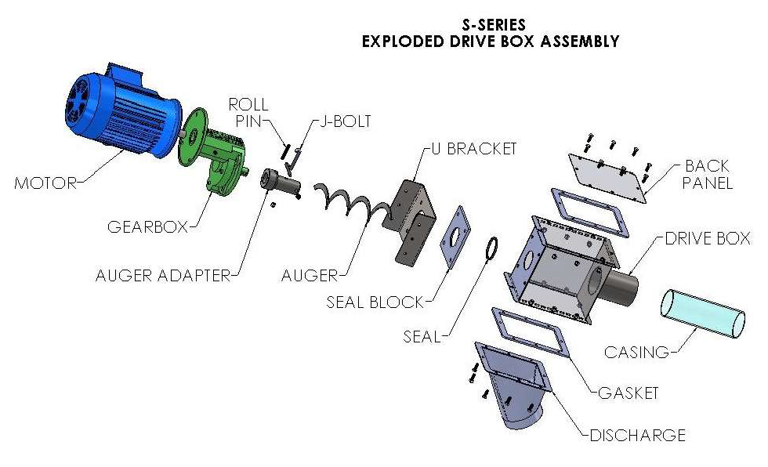
Warning: NEVER SERVICE OR DISASSEMBLE ANY PART OF THE FLEXIBLE SCREW CONVEYOR WITHOUT DISCONNECTING POWER AND FOLLOWING APPROPRIATE LOCK-OUT, TAG-OUT PROCEDURE.

Operation
Shown here is a blown-up view of our more common FSC systems.
- Flex Screw Conveyor (Cont.)
Safety
Important! Do not attempt to work on, clean, service the conveyor, open or remove any protective cover, guard, safety grid or maintenance panel until the POWER has been turned off and LOCKED OUT, and the conveyor motor has come to a complete stop.



Here’s a brief video over the operation of our FSC systems https://youtu.be/gNTXfEN4EjA

All owners/operators should read this manual and/or be instructed on safe operating and maintenance procedures before attempting to uncrate, install, operate, adjust or service this equipment.
Do not operate the conveyor unless all moving parts are covered and all guards, safety grids, and maintenance panels are in place and securely fastened.
Never place any part of your body or loose clothing under or near rotating members or moving parts of the conveyor auger or drive.
Many conveyors are installed and wired to start automatically or from remote- control locations. Keep clear of all moving parts at all times.
DO NOT attempt to remove or install end cap while conveyor is operating.
High-voltage and rotating parts can cause serious or fatal injuries. Installation operation and maintenance of electrical machinery must be performed only by qualified, trained and experienced personnel. Make sure that the motor and frame is effectively grounded in accordance with OSHA safety and health standards, the National Electric Code and local codes.
Any equipment which is used in the processing of explosive material in hazardous environments requires an evaluation on the part of the user and operator of proper and adequate equipment enclosures. Do not use your equipment in hazardous environments unless it has been properly equipped for the hazards.
It is ultimately the operator’s responsibility to implement the above-list precautions to ensure proper use of equipment maintenance and lubrication. Keep these instructions and list of warnings with your machines at all times. Work safety at all times.
Do no attempt to install, connect power to, operate or service your conveyor without proper instructions, and until you have been thoroughly trained in its use by your employer.

Operation
- Flex Screw Conveyor (Cont.)
Operation
Safe operation of the conveyor includes selection and use of appropriate safety accessories and controls specific for the conveyor installation. It is the responsibility of the system designer and requires consideration of equipment location and accessibility as well as operation with adjacent components.

Note: All safety accessories including, but not limited to the following, must be installed prior to start-up.
- Access covers and clean-out ports.
- Inlet hopper safety grid with safety interlock switch wired to control equipment.
- Guarding for sheaves and other rotating equipment.
- “Emergency stop” shut down.
- Provisions and fusible safety disconnect to equipment power feed.
- Operator instructions.
- Warning labels.
  - Check the tightness of all set screws, nuts, and bolts.

  - Verify that the supply voltage is correct, recheck motor wiring as necessary.

  - With the conveyor empty, jog the motor to verify the rotation of the auger. Rotation: the auger should rotate counterclockwise when viewed from the infeed end of the conveyor system,

  - Do not dry test the conveyor. Due to the nature of the unit’s conveying action, material is required to cushion the auger within the casing. The auger will begin to run smoothly once material enters the casing and fills the spaces within the casing.

  - Fill gearbox with OEM approved oil of necessary

  - Introduce a small amount of material into the auger infeed hopper. Energize the conveyor and add more material as it is conveyed upward. The conveyor will run continually smoother until the material begins to discharge.
The conveyor should never be run empty for periods of time longer than initial charging or emptying unless they are specifically designed to do so. A conveyor running empty will impose excessive fatigue on the components of the system. Likewise, a unit which is running with a full load of material and then “starved” will run rough and fatigue its components, although not as severely as when operating completely empty.
Inlet hopper vibrators (electric or pneumatic) should not be operated when the hopper is empty. The exception would be for the short time during clean out.

.

Operation
- Flex Screw Conveyor (Cont.)
WARNING

Extreme hazard: Do not reach hand into or allow clothing to come in contact with infeed hopper or hopper boot opening. Do not disable safety grid or safety interlock switch.

Place a catch basin under the boot end, using the reverse job button on the control panel; reverse the direction of the auger by making contact in 3-5 second incremental surges. This “jogging” will remove most of the material from the casing.

Perform Lockout & tag out (LOTO) anytime operator intervention with the auger (or rotating components) is required.

Replacement parts are available through our parts Dept. please have your serial number available when calling.

Maintenance
FormPak FlexFlo Flexible Screw Cleaning Instructions:

One of the advantages of flexible screws over nearly any other type of conveyor is the ease in which they can be cleaned. Below are instructions on disassembly for both the standard and the Clean-Flo styles of flexible screws FormPak offers. Cleaning processes, procedures, and chemicals for making these parts “sanitary” are customer and site specific and therefore not included here.

Basic Clean – No Disassembly

It should be noted that these conveyors can be cleaned without disassembly in either a dry or wet fashion. In either case, the end cap is removed and the screw is run in reverse to facilitate material evacuation. Steps:

Warning!
It is important to note that the conveyor should never be run in reverse if the clean-out cap has not been removed or if there is still a significant head load of material above the in-feed of the conveyor. Either of these two conditions can cause conveyor auger failure.

- Remove the (2) clips that hold the end cap to the infeed hopper outlet
- Run conveyor in reverse
- Air (for dry clean) or water can be added at the discharge head (be cautions of the rotating screw – fingers, hands, or hoses may be pulled into the conveyor) or the infeed hopper.
- With system on “Off” position and locked-out, the infeed hopper and discharge head can be wiped down.

Full Disassembly – Standard Unit

- Remove the (2) clips that hold the end cap to the infeed hopper outlet
- Remove the panel from the top of the discharge head (4 bolts)
- Remove the J-bolts holding the auger to the drive shaft (note the auger is now free and may drop out of the conveyor as the J-bolts are loosened. Securing the end of the screw at the outlet may be required).
- Augur can now be pulled out from the infeed hopper (bottom of conveyor)
- Loosen the lower compression coupling holding the Conveyor Tube to the Hopper tube.
- Slide the compression coupling up the Convey Tube to release it from the Hopper Tube (note the Convey Tube may slip out from the top compression coupling, be prepared to secure this from both ends)
- Lower compression coupling can now be slipped off of the Convey Tube
- Upper compression coupling can now be loosened and slid down Convey Tube
- Convey tube can now be removed from Discharge Head
- If there is a connection to the infeed hopper (typically a flexible boot held with clamps) it can be removed for access to top of infeed hopper
- The top of the hopper is typically bolted or clamped, and can be removed for ease of cleaning hopper. (Drive should be locked out prior to cleaning this hopper if auger is still in place)

Maintenance

Full Disassembly – CleanFlo Unit

- Remove the (2) clips that hold the end cap to the infeed hopper outlet
- Using the Tri-Clover top cover on the Discharge Head, the top access panel can be removed:

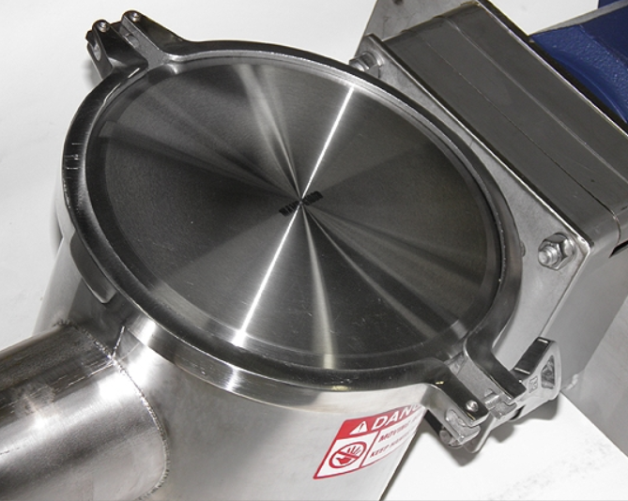 | 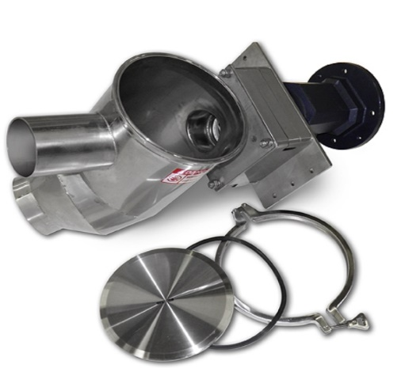

- Between the Discharge Head and Drive is a bolted pin to release the augur:

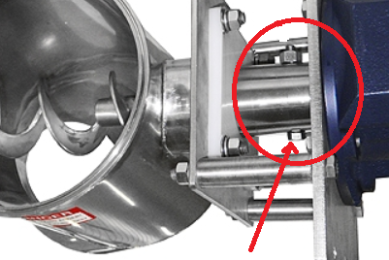

(Note once this pin is pulled, the auger is free and may drop out of the conveyor. Securing the end of the screw from the outlet may be required).

Maintenance

Full Disassembly – CleanFlo Unit - Continued

- Augur can now be pulled out from the infeed hopper (bottom of conveyor)
- Loosen the lower compression coupling holding the Conveyor Tube to the Hopper tube.
- Slide the compression coupling up the Convey Tube to release it from the Hopper Tube (note the Convey Tube may slip out from the top compression coupling, be prepared to secure this from both ends)
- Lower compression coupling can now be slipped off of the Convey Tube
- Upper compression coupling can now be loosened and slid down Convey Tube
- Convey tube can now be removed from Discharge Head
- If there is a connection to the infeed hopper (typically a flexible boot held with clamps) it can be removed for access to top of infeed hopper
- The top of the hopper is typically bolted or clamped, and can be removed for ease of cleaning hopper. (Drive should be locked out prior to cleaning this hopper if augur is still in place)

Reassembly

Regardless of the type of flexible screw, the reassembly process should be done in exactly the reverse of the process used to disassemble.

FormPak Machinery Catalog

BagPak Series (Bulk Bag Fillers)
- BagPak 1100-DT (Duffel Top Bag Filler)
- BagPak 2100-ST (Spout Top Bag Filler)
- BagPak 2100-SS (Spout Top, Scale Controlled Bag Filler)
- BagPak 4400-AD (Auto Discharge Bag Filler)

BagFlo/EasyFlo Series (Bulk Bag Dischargers)
- BagFlo 500-FL (Fork Loaded Bulk Bag Unloader)
- BagFlo 500-HT (Hoist & Trolley Loaded Bulk Bag Unloader)
- BagFlo 500-HF (Half Frame Bulk Bag Unloader)
- BagFlo 500-RK (Retrofit Kit)
- EasyFlo 500-FL (Free Flowing Bulk Bag Unloader)
- EasyFlo 500-HT (Free Flowing Bulk Bag Unloader)
- EasyFlo 500-HF
- BagFlo LIW (Loss-in-Weight Bulk Bag Unloader)
- BagFlo GC (Gantry Crane Bulk Bag Unloader)
- BagFlo SLH (Super Low Head)

Lifting Devices
- BagLift 100-CA (Bulk Bag Crane Adapter)
- BagLift 100-FA (Bulk Bag Fork Adapter)
- BagLift 100-FF (Flying Fork Adapter)
- BagLift 100-LH (Low Head)
- BagLift 200-HL (High Lift)

Small Bag Handling Equipment (Bag Break Stations)
- BagBreak 100-SH (Simple Bag Break Hopper)
- BagBreak 400-UC (Bag Break with Upper Cabinet)
- BagBreak 400-DF (Dual Filter Bag Break)

Other Products
- FlexFlo Flexible Screw Conveyors
- FeedFlo-VSF (Volumetric Screw Feeder)
- FeedFlo-VFV (Vibratory Volumetric Feeder)
- FeedFlo-SFS (Screw Feeder with Scale)
- FeedFlo-VFS (Vibratory Feeder with Scale
- FeedFlo LIW (Loss-In-Weight) feeder
- GH-1000 (Gyrated Hopper)
- VM-4000 (Venturi Mixing System)
- MatFlo (Lump Breaker)
- BagBreaker (Bag Conditioner)
- Live Hoppers
- Eduction Systems
- Batching Systems

