FORMPAK INC

DISCLAIMERS:

NOT ALL ITEMS IN THIS MANUAL ARE ON EVERY SYSTEM.

SYSTEM CONFIGURATIONS VARY PER CUSTOMER ORDERS & SPECS.

ANY MODIFICATIONS TO THE EQUIPMENT WITHOUT APPROVAL OF FORMPAK ENGINEERING WILL RESULT IN VOIDING ANY WARRANTY.
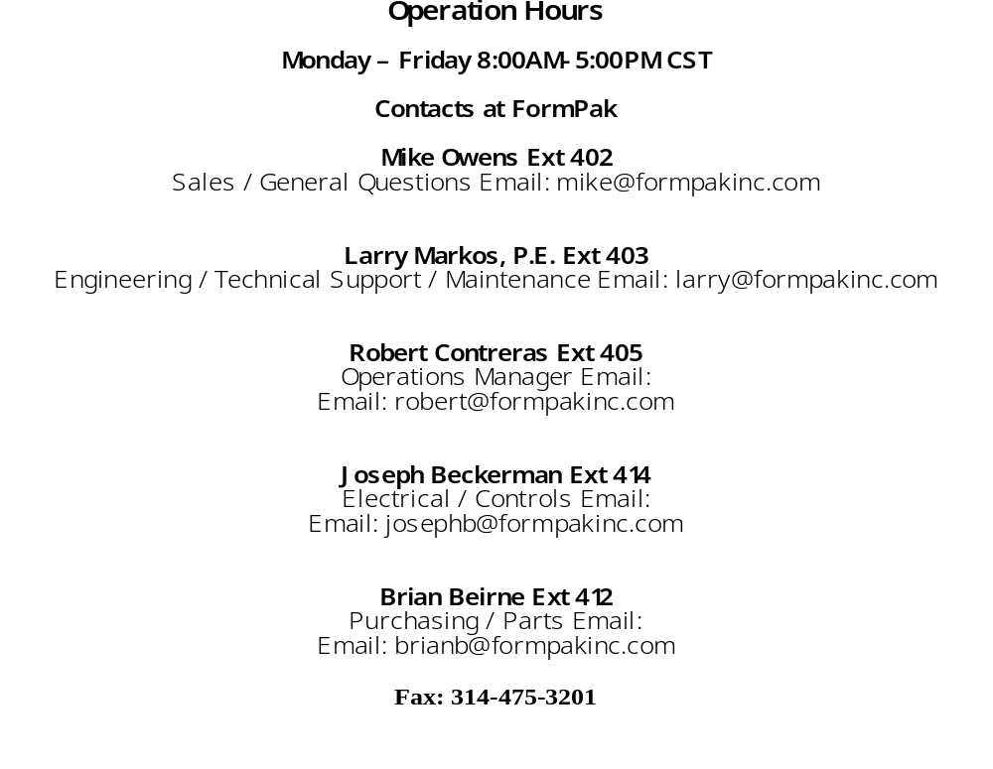

4400 RL iom
2021 eDITION

4400 RL IOM INDEX
Section Page
  - Concept Of Operation 2
  - System Components 3-4
  - Installation 5
  - Electrical 6
  - Pneumatic 6
  - Bag Filling and Hanging 6-8
  - Control Panel 9
  - Scale Controller Operation 10-14
  - Load Cells & 920i Calibration 15-17
  - Load Cell Unit Change 18-20
  - Maintenance 21-27
  - Formpak Machinery Catalog 28

- Concept of Operation

The BagPak 4400-AD-RL is basically an open bag on a computer monitored scale. As material is poured into the bag, the weight is tracked by the scale controller. The bag is filled FAST until it gets close to the final weight, then it fills SLOWLY to ensure accuracy. The actual operation and interface are a bit more complicated.

The computer controlling the BagPak 4400 is the Rice Lake 920i Scale Controller. The scale controller monitors the input from the built-in load cells and provides that information to the PLC. The PLC controls the valves, air cylinders, conveyors, etc in the filling machine. We often say the scale controller is the brain, and the PLC is the muscle.

Four discrete signals come from the Scale Controller:
- Fast fill signal
- Slow fill signal
- Vibration sequencing
- End of cycle. This start the chain of events to eject the filled bag.

See the section on Scale Control for additional details on the Scale Controller. Pages (11-16)

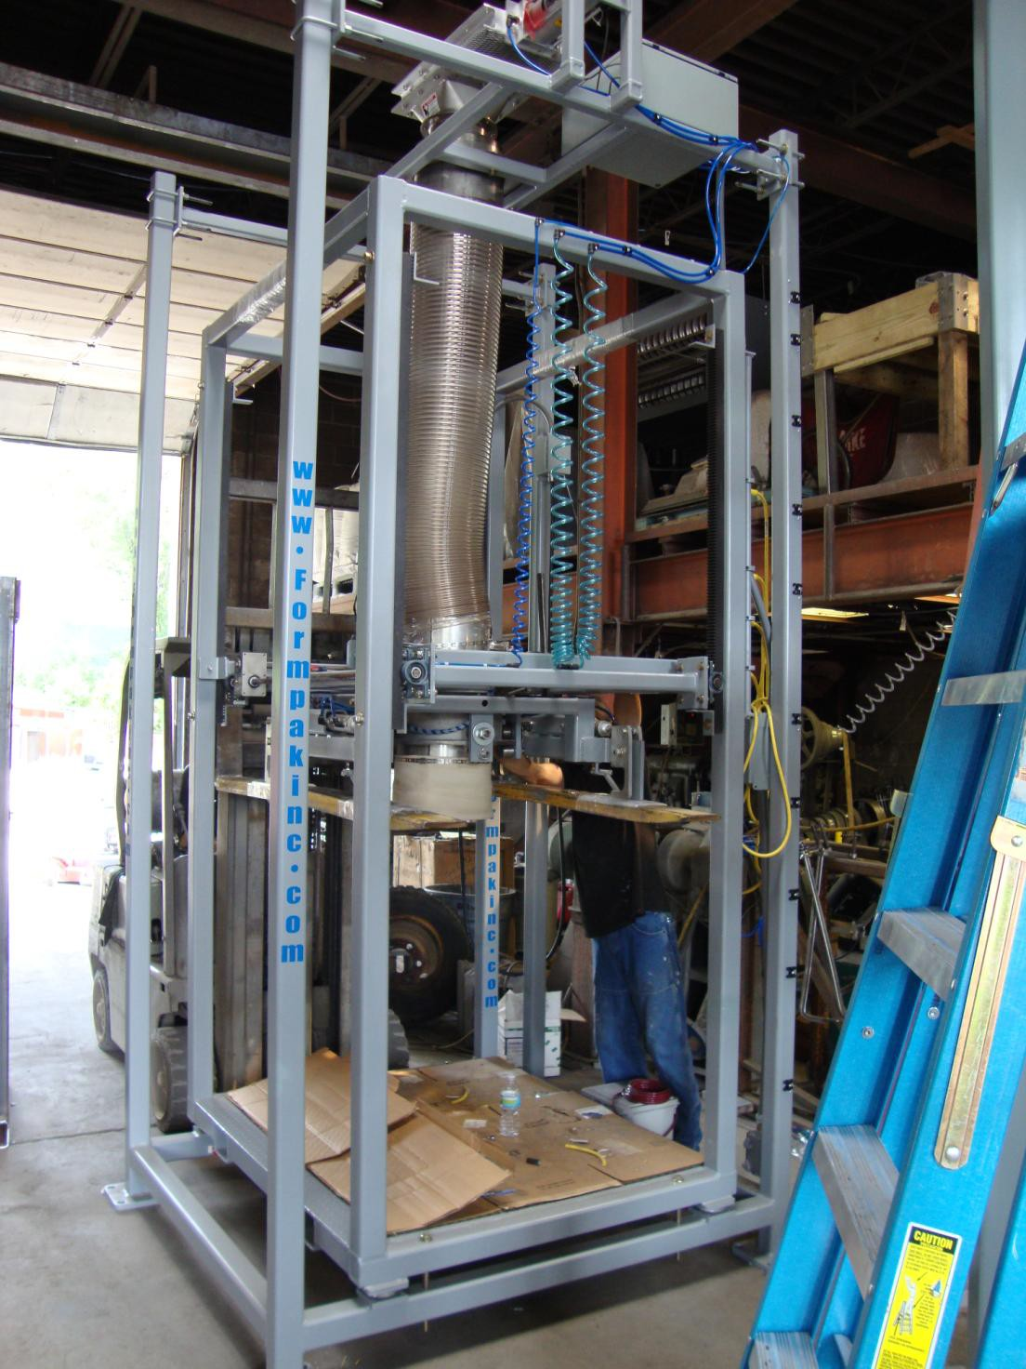
- System Components
Upper Frame U-Bolts
Air Control Box
Gate Valve
Load Cells
Frame Bolts
Anchor Feet
Inflation Boot for bag spout
Rota-Load Assembly
Flexible Fill Tube

- System Components (Cont.)
The machine pictured has an inner and outer frame. The outer frame supports a slide gate when it’s not possible to support the slide gate on existing equipment. The outer frame is not “on the scale”, so anything attached to it, will not affect scaling functions. The Flexible Fill Tube, gravimetrically separates the inner frame, (which is on the scale) from the outer frame, which is not on the scale. This separation, ensure accurate weighments.

The Upper Frame bolts provide adjustment of the vertical position of the slide gate. Raise or lower the upper frame to provide more or less clearance for the slide gate.

The Slide Gate Valve controls flow of material into the bulk bag. These valves typically have three positions: fully open, partially open, and closed.

Flex Fill Tube guides the material into the fill head of the filling machine.

The Rota-Load supports the bulk bag by its lift loops.

Inflation boot seals the bulk bag to the machine when the boot is inflated.

Load cells provide the weight signal to the scale controller

Frame bolts must be left loose, once the load cells blocks are removed.

Anchor feet should be epoxy style and have at least 4” of contact with the concrete.

- Installation
The BagPak 4400-AD is typically too tall to ship standing upright, so it comes to you laying on its side. Everything on the machine has been blocked for shipping. All these blocks and bands should be left in place, when erecting the machine. The machine can weigh 3,000 lbs. or more. Be sure to have qualified, erect it. See the mechanical drawings for the exact weight of your machine.
Before erecting, check to ensure the shipping bolts are still tight and the load cells and blocks have not shifted. Leave these shipping bolts tight and the shipping blocks in place until the machine is anchored in place and the conveyors are attached to the top.

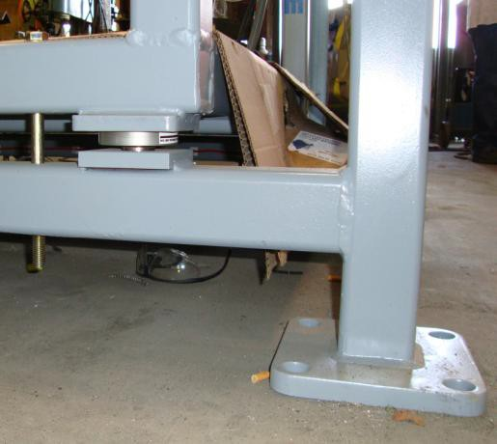
Frame Bolts
Load Cells
Anchor Feet

Shock loading and welding are the number one cause of load cell failure during start up. If welding needs to be done on the machine, please consult FormPak engineering.
The machine must be level. Millwright should shim the anchor plate if the floor is nearly level. If the floor is very uneven, grout pad may need to be used.
Once the machine is anchored, the upper section can be raised to meet the equipment above. The design of the BagPak 4400-AD allows hard connections to the upper section. The scale is gravimetrically isolated from the upper section. U-bolts on the vertical supports can be loosened and the upper section may be raised or lowered as required. If it is lowered, the flexible tube between the upper and lower sections may need to be removed and shortened. Loosen the band clamp, then twist and pull to get one end free. The tube can then be cut as required. Be sure some slack remains in this tube at all times. If this is pulled or compressed too much, the accuracy of the scale can be affected. See the item locations in the photo in section II – System Components.

Electrical
A qualified Electrician must connect the three-phase power to the control box. Consult the electrical drawing for the proper service for this machine. In nearly every machine, the power is dropped to the main control panel, and field wired to the various components from the main box.

See the electrical drawing for exact details of what options require wiring on your machine.

Pneumatic

A compressed air supply will need to be connected to either a solenoid block within the main control panel or to a separate air control box depending on your options. See the Air Schematic for details of the pneumatic system. The air provide to the machine must be clean and dry. If you have any doubt, put a filter regulator on the air line to the machine.

Air lines from Air Box enclosure lines are all factory installed. Clean, dry plant air must be supplied.80 PSI minimum required.

Bag Filling/Hanging

- Set the machine to the correct height for the bag being filled.
- Adjust the Scale Controller, vibration points and times, and FILL and TRIM weights (see below for details on how to do this).
- Place a stack of pallets on the Pallet Feeder
- Start the pallet feeder to stage the first pallet.
- Use "Manually Feed" button to feed the first pallet into the filling machine.
- Hang the Bulk Bag (see photos and description below), and inflate the Inflation Boot (Seal)
- Pre-inflate the Bag with the air multiplier (or Service Air Control Valve), if required.
- Start the filling cycle.
- Once complete, the machine will eject the filled bulk bag onto the accumulating conveyor.
- A new pallet will be automatically fed into the filler.
- Hang a new bulk bag and continue from step 6 above.

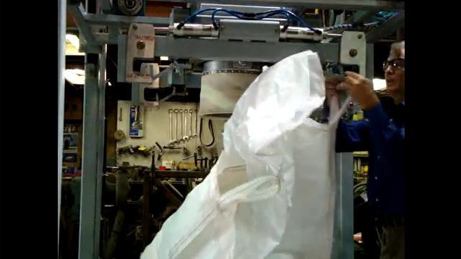
Bag Filling/Hanging (Cont.)
Place two of the bag lift loops on the hooks closest to the operator. Rotate the Rota-Load carriage 180 degrees and hang the other two lift loops on their hooks.

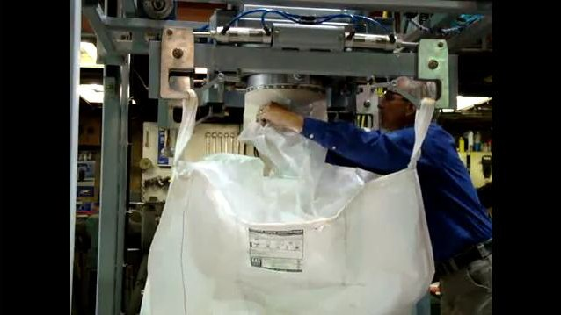
Pull the bag spout up and over the inflation boot (seal) … top photo then press the green button to inflate it … bottom photo. Green button inflates the Boot, Red button deflates the Boot. Machines auto deflate at end of cycle.

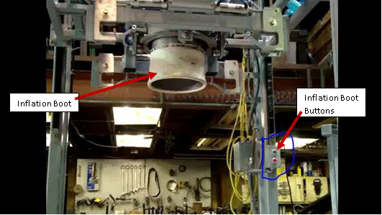
- Bag Filling/Hanging (Cont.)

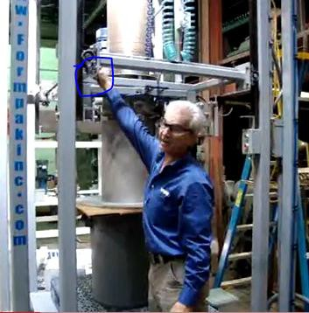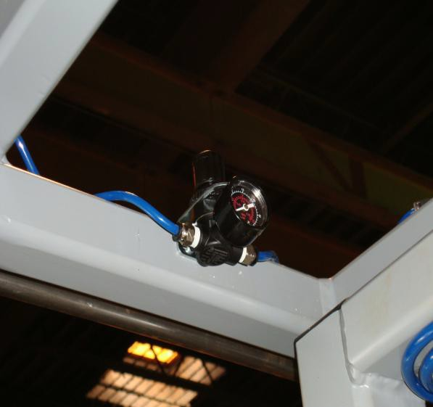
Air Pressure Regulator
Adjust the air pressure to control boot tightness. Boot should be tight, so spout is securely held in place, but it only takes 5 psi max. If you set the pressure too high, the bag spout may fail.
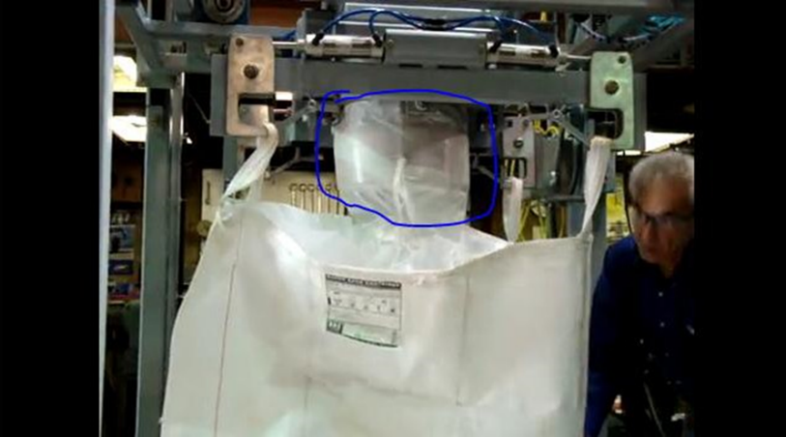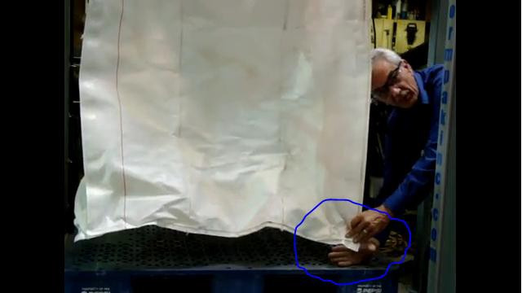
After the bag is hung, check the hanging height. The top photo shows the correct height. If this bag is too low (as in the photo below) it will not fill properly and will only hold a portion of its capacity. It could then slump in an unsafe manner. It is very important to hold the bag about 3” - 4" above the pallet before any material enters the bag.
Use the manual carriage buttons to raise or lower the bag to a proper height if your machine has that option. If it does not, the Rota-Load must raised or lowered (with a forklift) so the bag hangs at the correct height. Hanging the bag at the proper height is critical for proper bulk bag filling.

It is highly recommended to watch the video on this link … http://www.youtube.com/watch?v=UmI9N5iN7B4&feature=related

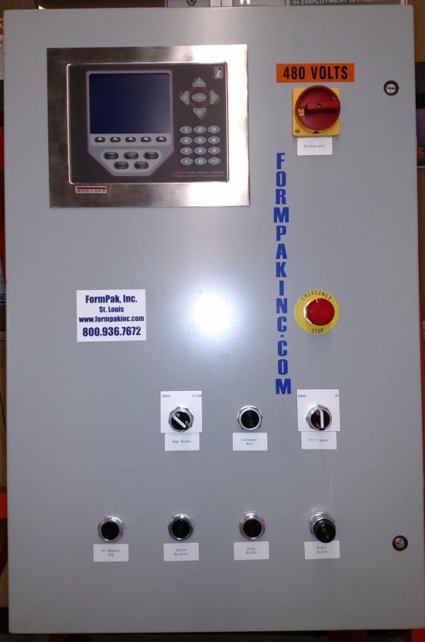
Control Panel
Start Scale
Slidegate Jog
Stop Scale
Scale Gyrator
Fill Head Up / Down
Bag Hooks Open / Close
E - Stop
Conveyor Run
Scale Controller
Disconnect for power lock-out when cabinet door is open

- Scale Controller Operation
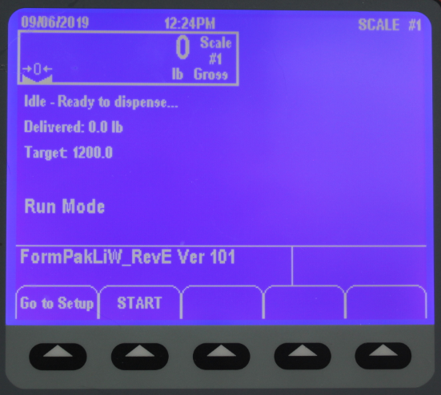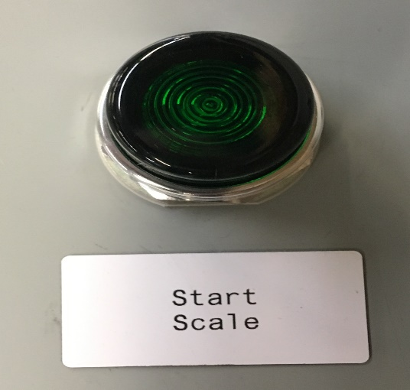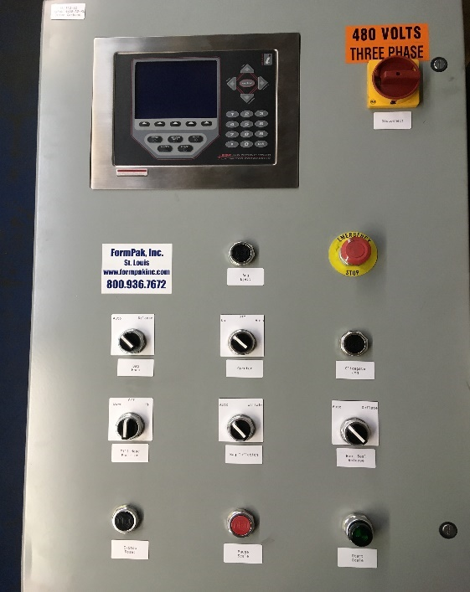
Actual weight in bag as it is being filled.

Target weight; This is the desired weight.

The is the soft key to press to start the filling cycle.

Start scale, external button. Lights up when pressed.

Scale Controller Operation (Cont.)

This is the screen you will see when the machine is running. It shows the weight in the bag (761 pounds), the target weight (2000), the last competed weight (2002.7), and the machine is in "Run Mode,” which means material is being added to the bulk bag.
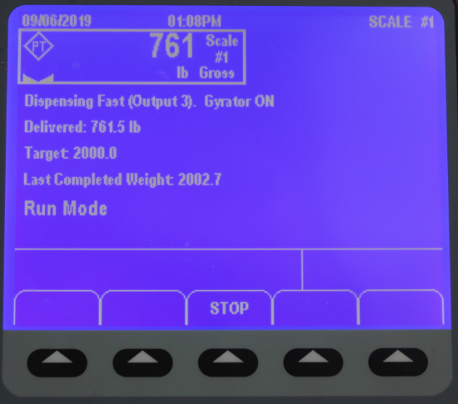 The scale controller monitors the flow of the material going into the bag. If this flow is too slow, the machine will pause the batch. The screen below is what you will see if this happens. In most cases, you'll want to get a supervisor to help figure out what is wrong.
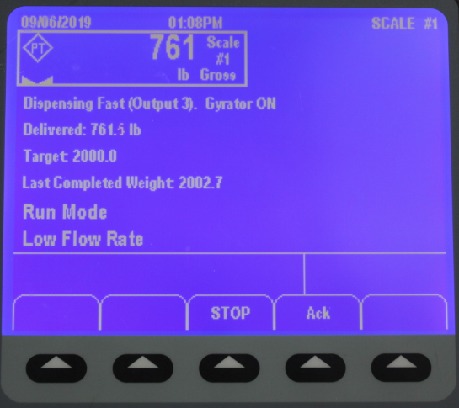
Low Flow Rate.

The machine has determined the flow into the bag is too slow, and has paused the machine.

Scale Controller Operation (Cont.)


Situations may arise when the machine needs to be stopped. Pressing the "STOP" soft key will halt delivery of material to the bag. If you do press the STOP button this is the screen you will see.

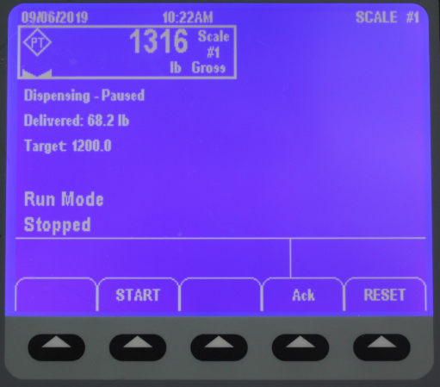
This screen shows that the aborted bag had 68.2 pounds in it, when the machine was stopped.
To reset the machine, press the “RESET” soft key, then press the “Ack” soft key to return to the screen below, and continue to fill the bag.

If you are able to easily 'fix' the problem, and you want to continue to fill the bulk bag, press the "START" soft key and the machine will continue filling the bag, to the correct Target weight. As soon as you press the “START” soft key to restart the machine, you will see the screen below.

Scale Controller Operation (Cont.)

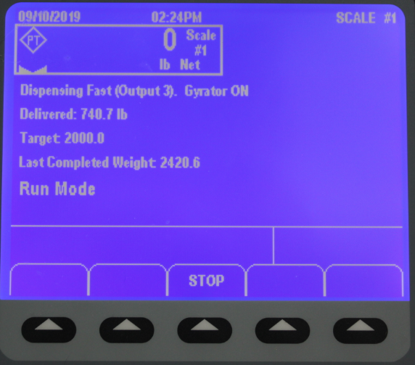
Important things to note on this screen. The scale now shows zero pounds. This was reset by the STOP button, but the “Delivered” line shows what is actually in the bag at the moment of restart, and this will continue to show the actual delivered amount of material in the bag. If you are unable to easily fix the problem, and the bag needs to be removed and a new filling cycle started, you will see the screen below. Once the partially filled bag has been removed, you will see this screen.
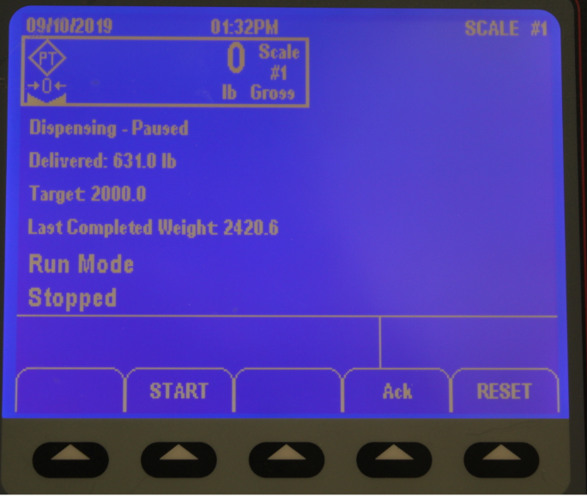
This screen shows that the aborted bag had 631 pounds in it, when the machine was stopped.

To reset the machine, press the “RESET” soft key, then press the “Ack” soft key to return to the screen below, and continue to fill the bag.

If you are able to easily ‘fix’ the problem, and you want to continue to fill the bulk bag, press the “START” button and the machine will continue filling the bag, to the correct Target weight. As soon as you press the “START” button to restart the machine, you will see the screen below.

Scale Controller Operation (Cont.)

Once the bag is filled, you will see this screen:
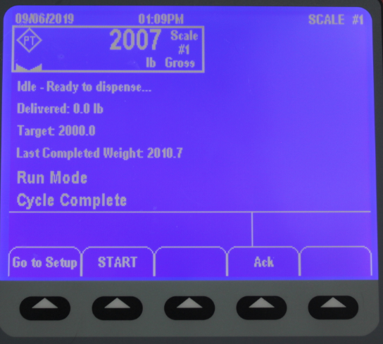
This indicates that the cycle is complete and the bag is filled.

WARRANTY

A full one-year, limited warranty against manufacture or component defects, includes replacement of parts and labor.

CONDITIONS

System is unconditionally guaranteed to work only if a sample of material to be handled is delivered for testing. Quote does not include on site mechanical or electrical installation, field service, or start-up. Also does not include any applicable state and local taxes, or permitting costs. Credit references must be provided prior to acceptance of order. LTL shipments will be charged an additional crating charge not to exceed $350. Additional terms and conditions apply, please request full disclosure prior to order.
TERMS

Quote: Good for 30 days from date of issue.
Leadtime: In Stock
Payment: Net 30
FOB: St. Louis, MO

- Load Cells & 920i Calibration
First Calibration of operation must be done by a qualified scale professional.

This is the procedure to calibrate the Rice Lake 920i Scale controller. In order to be legal for trade, this device must be calibrated by a qualified scale technician. Each state has a different set of regulations for scales; be sure you know the laws in your area and have your equipment calibrated to those local regulations.

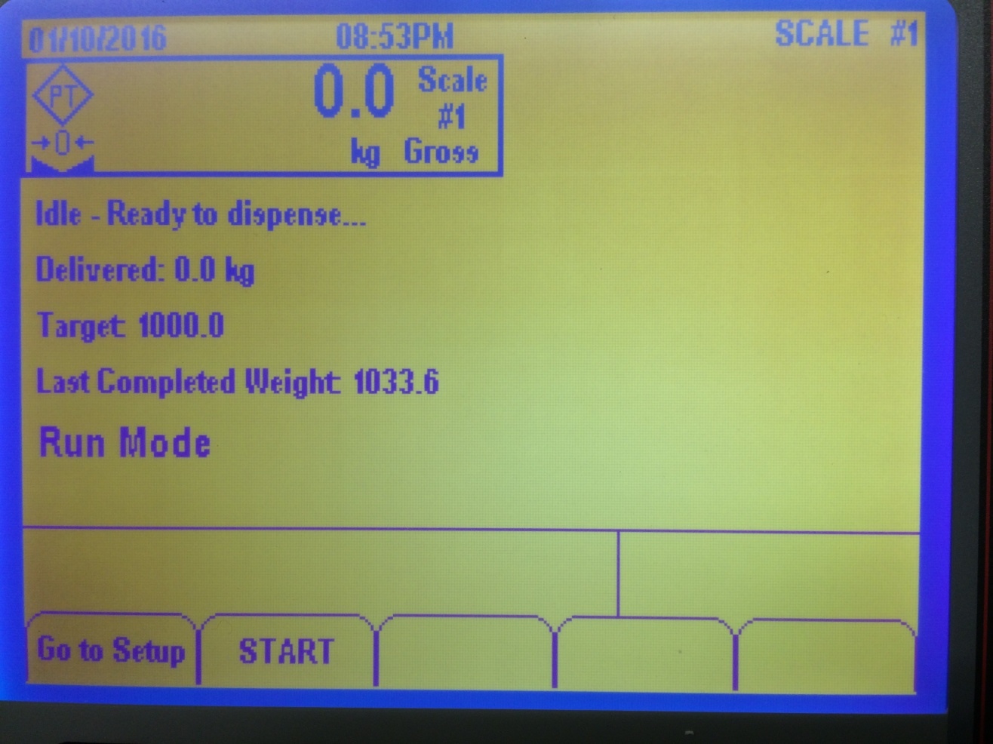
This is the opening screen when the controller is turned on. The machine must not have a bulk bag loaded when calibrating.

To begin calibration, the controller must be put in “Calibration” mode. To do this, a small square yellow button on the rear of the controller must be pressed. Its location can vary depending on the model, but it is the only one like it on the unit. Remove the screw covering it and press it once.

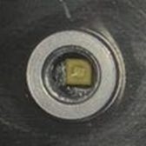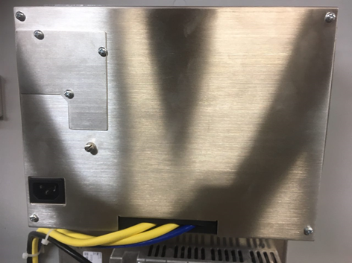

Load Cells & 920i Calibration (Cont.)
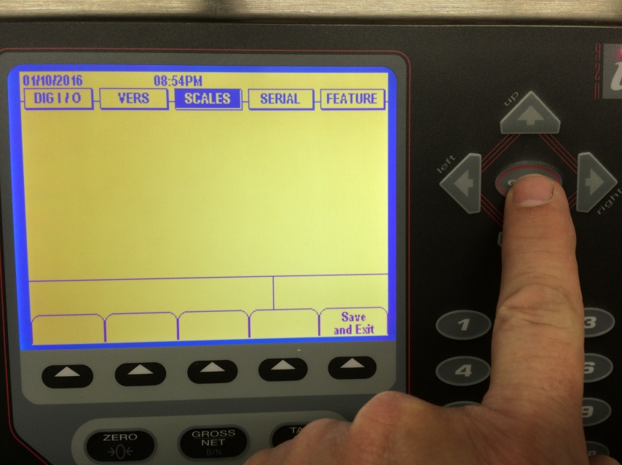
This is the screen you will see once the button is pressed. It indicates the scale is in set up mode, so it can be calibrated. Use the four arrows and Enter button to navigate and enter data during calibration.

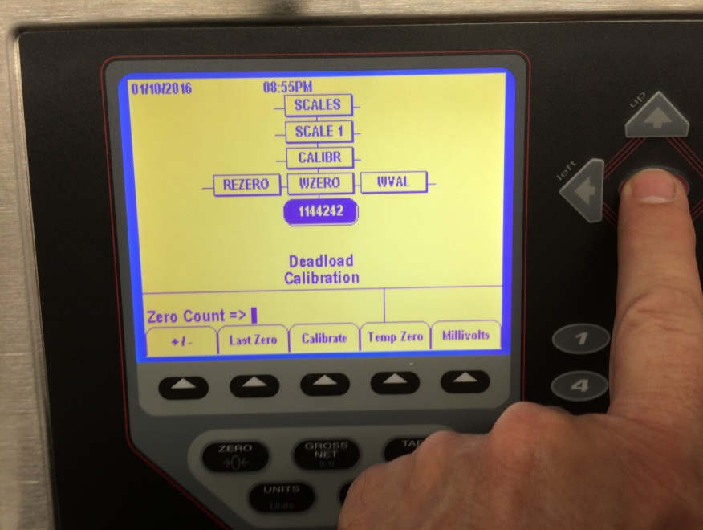
Navigate to “SCALES”, “SCALE 1”, then “CALIBR” using the arrow buttons.
Next, press the down arrow again to see the screen above. This is the first calibration point. With no weight on the scale, press the soft key under “Calibrate”
“Calibrating…. Deadload” will flash below. Once it stops flashing, press the enter button to store the results.

Load Cells & 920i Calibration (Cont.)
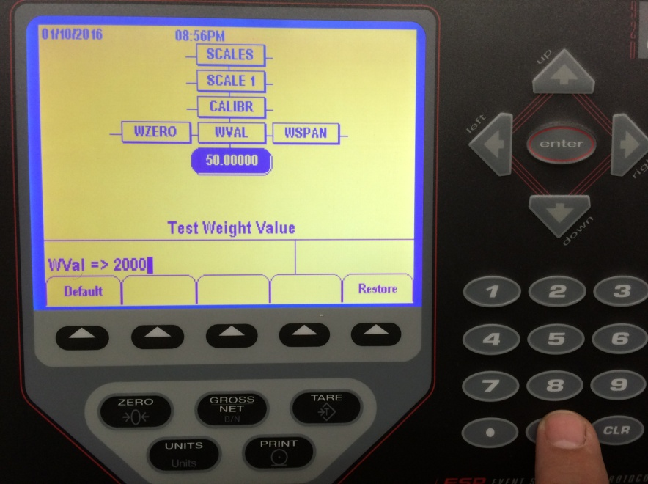
This screen appears after the enter button is pressed. At this point, set the test weight(s) on the scale and enter the value of that weight. In this example, the test weight is 2000#. Once the weight has been entered on the number pad, press the Enter key.

“Value accepted” should appear. Now press the Save and Exit soft key.” Standby Saving Configuration” will flash.

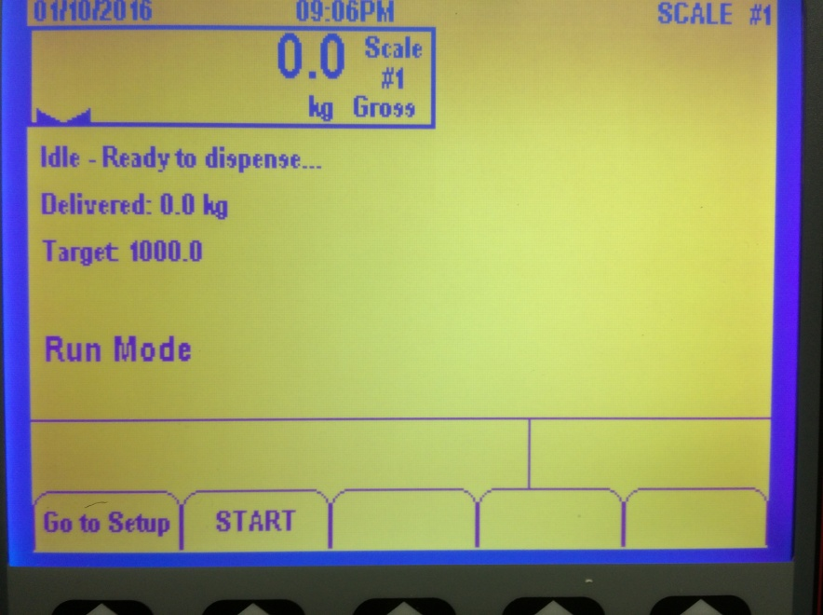
After Save and Exit. This screen indicates the machine is back in Run Mode and that calibration is complete.

- Load Cell Unit Change
Changing the units will require a new calibration.
After pressing the "set up" button, navigate down your scale tree. Click on GRADS then go right to Format.
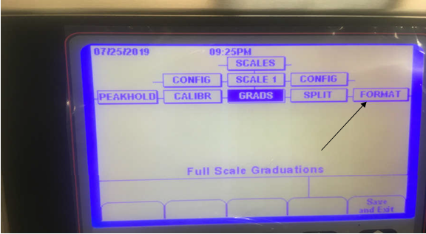
Now go down to PRIMAR, then down to DECPNT.
Once there, go over to units. Once at UNITS press down and your UNIT options should appear on screen. Once you find the correct UNIT your wanting select ENTER.

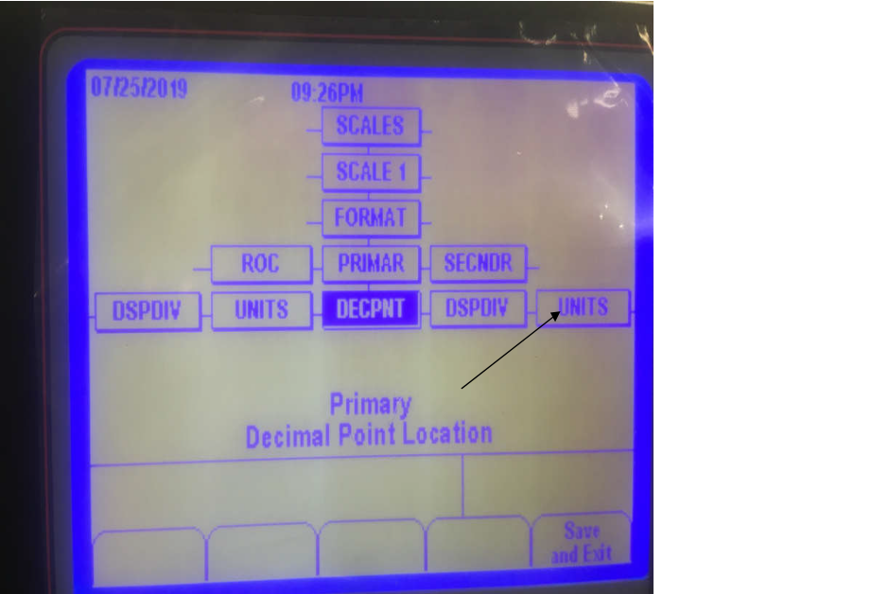

- Load Cell Unit Change (Cont.)

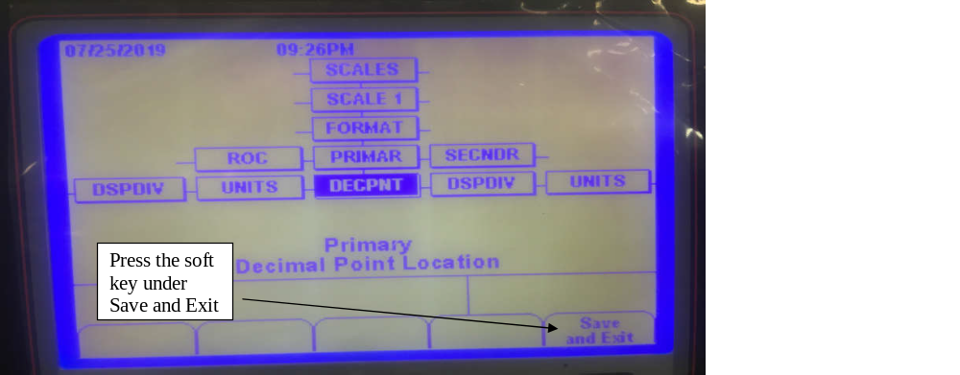
You are now back at the DECPNT screen. If no further changes are required, press the
Save and Exit button, to save your changes. However, if you need to change the decimal point press the down arrow key once.
This is the decimal point screen. In most cases, select no decimal point. Shown below.
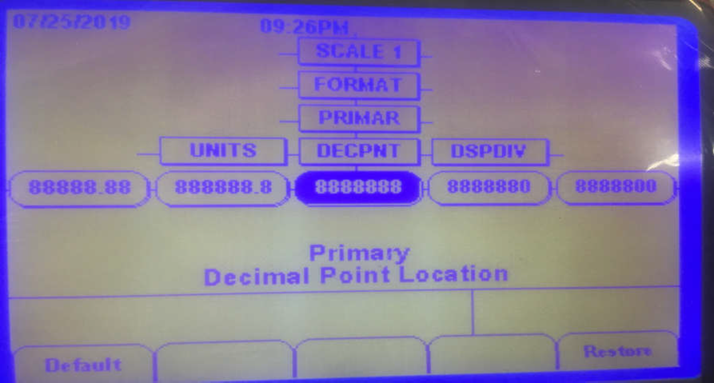

- Load Cell Unit Change (Cont.)
This is the decimal point screen. In most cases, select no decimal point. Shown below.

Press the Enter key and the DECPNT screen comes back. Now press the Save and Exit button. The *Standby* message will appear to let you know your changes are being saved. Press the "Save and Exit" button, to save your work.

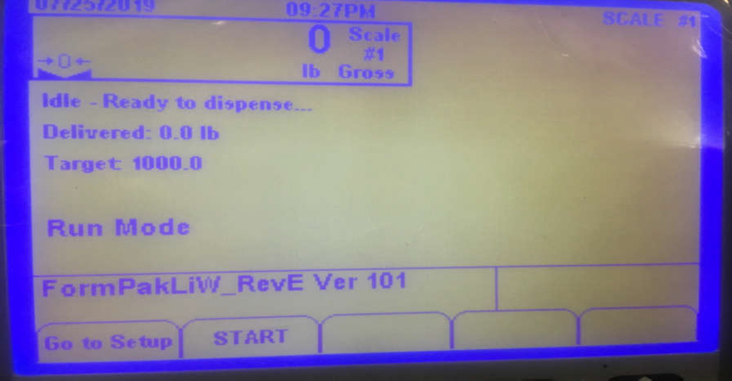 When this screen appears, the scale is back in RUN mode.

- Maintenance
Preventative Maintenance Recommendations – BagPak 4400-AD

In general, the FormPak BagLoad4400 was designed so that very little maintenance is required. The items below are possible wear points and lubrication recommendations.

Bag Inflation Seal: At some point, this will need replaced. A small leak may go unnoticed since the pressure is so low the regulator will compensate for these in many cases. To inspect for a leak, inflate the boot, then cut off the air supply. If the boot deflates, most likely there is a leak in the boot. The gum rubber boot will last one or two years in most applications.

Motor - Up/Down carousel carriage: A dry lubricant can be applied to this once per month. Avoid grease as dust accumulation can create issues.

Motors - Roller Conveyors: have sealed bearings. No maintenance is required.

Bearings and Chains - roller conveyors: See attached Omni Conveyor Manual for requirements.

Bearings - RotaLoad carriage: These are sealed bearings, so no lubrication is required, but the clearance between the bearing and the ring may need adjusting. See Figure 1 below. The bearing with the shoulder has an eccentric shaft which allows adjusting the clearance on the RotaLoad. To adjust this clearance, turn all four (4) eccentrics until there is nearly no clearance and the RotaLoad is 'stiff' to turn. Back off each eccentric, just slightly, so the RotaLoad turns freely, and tighten the lock nuts.

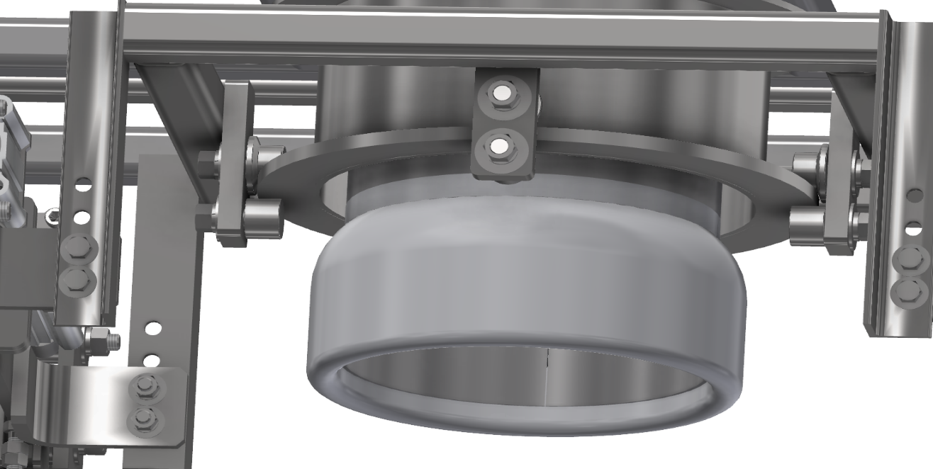
Adjustable eccentrics, four places.
Figure 1.

Gear Track - Up/Down Carriage: Annual inspection for wear.

Bearings - Gear Track: Lubricate annually with synthetic grease.

Air Cylinders and Solenoids: Never lubricate these systems. Any sort of lube will ruin the lifetime coating on these parts. Clean, dry air is essential, moisture will damage and/or shorten the life of these components.

- Maintenance
Gyrator Force Adjustment

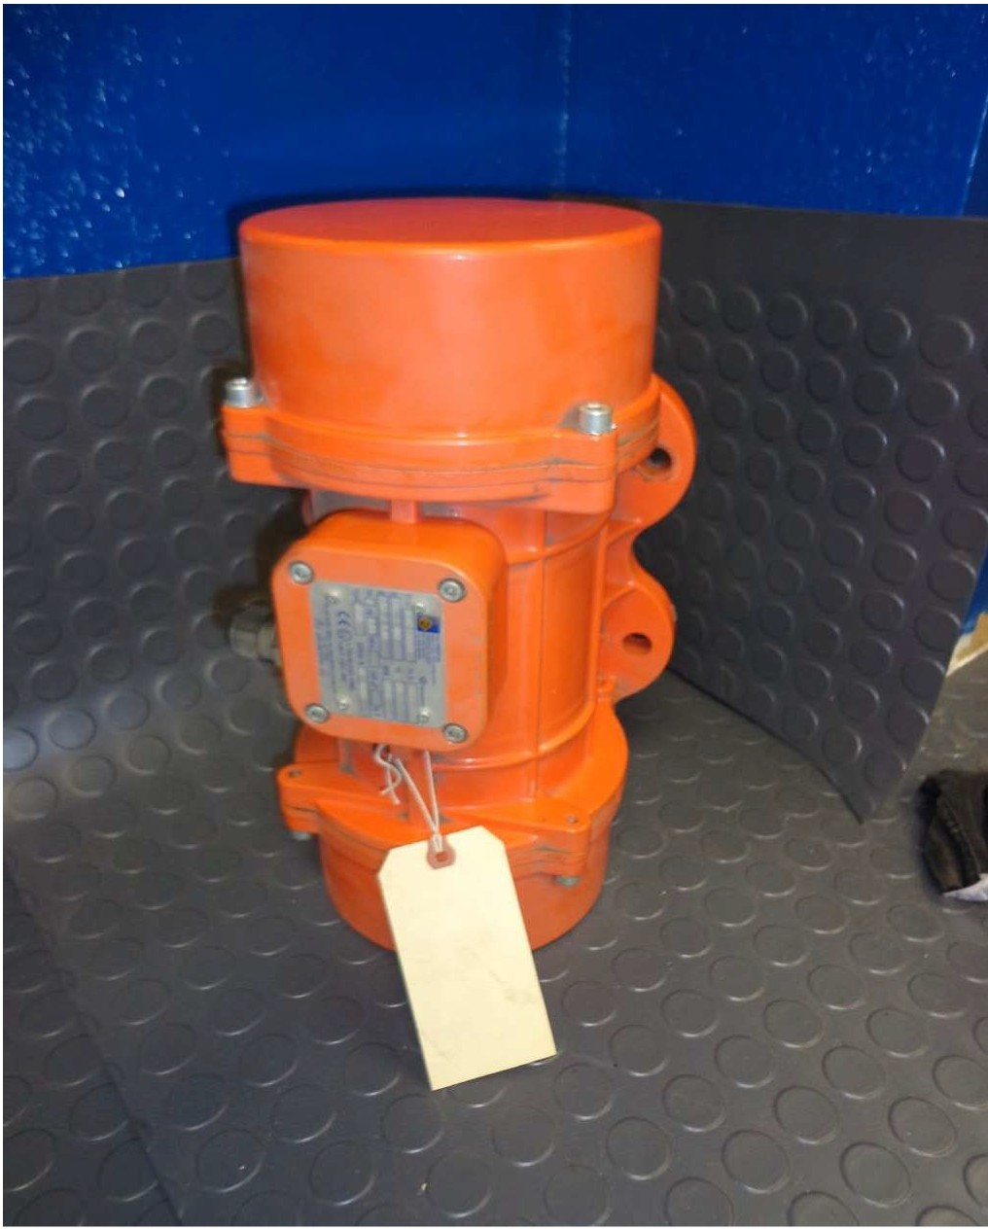
The pounds force provided by the Oli Gyrator is adjustable up to about 1500 lbs-force. To make these adjustments, the end caps must be removed from the gyrator.

Using the lowest setting that will let material flow or pack is always the best. Start with a low setting and adjust the force upward, until the desired flow or compaction is attained.

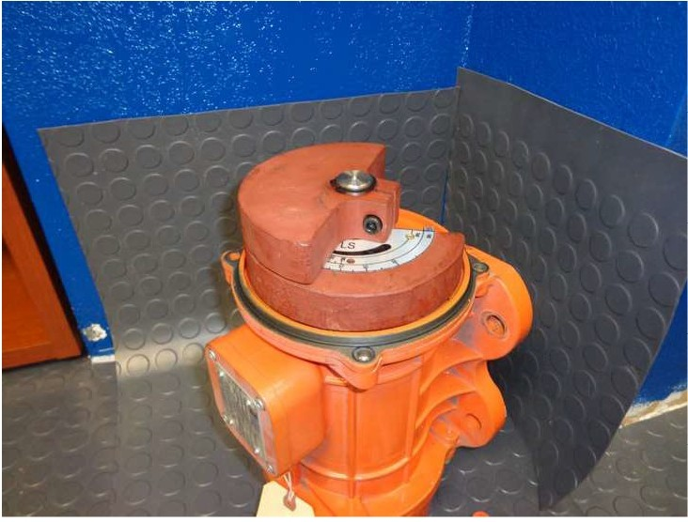
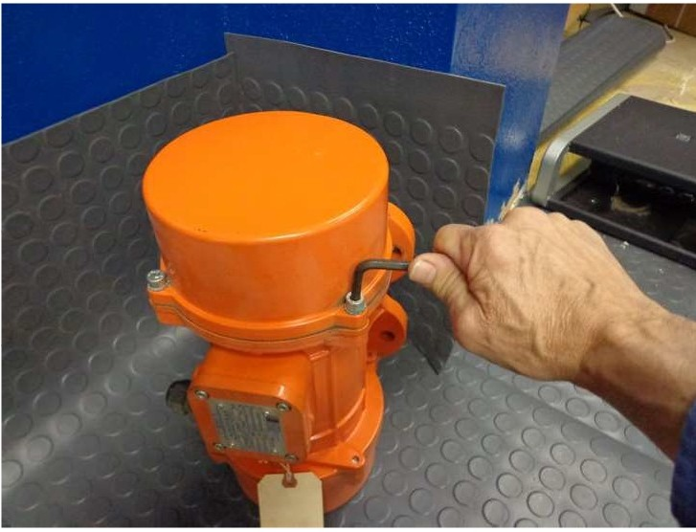
Remove the four cap screws from each end cap and remove the caps.

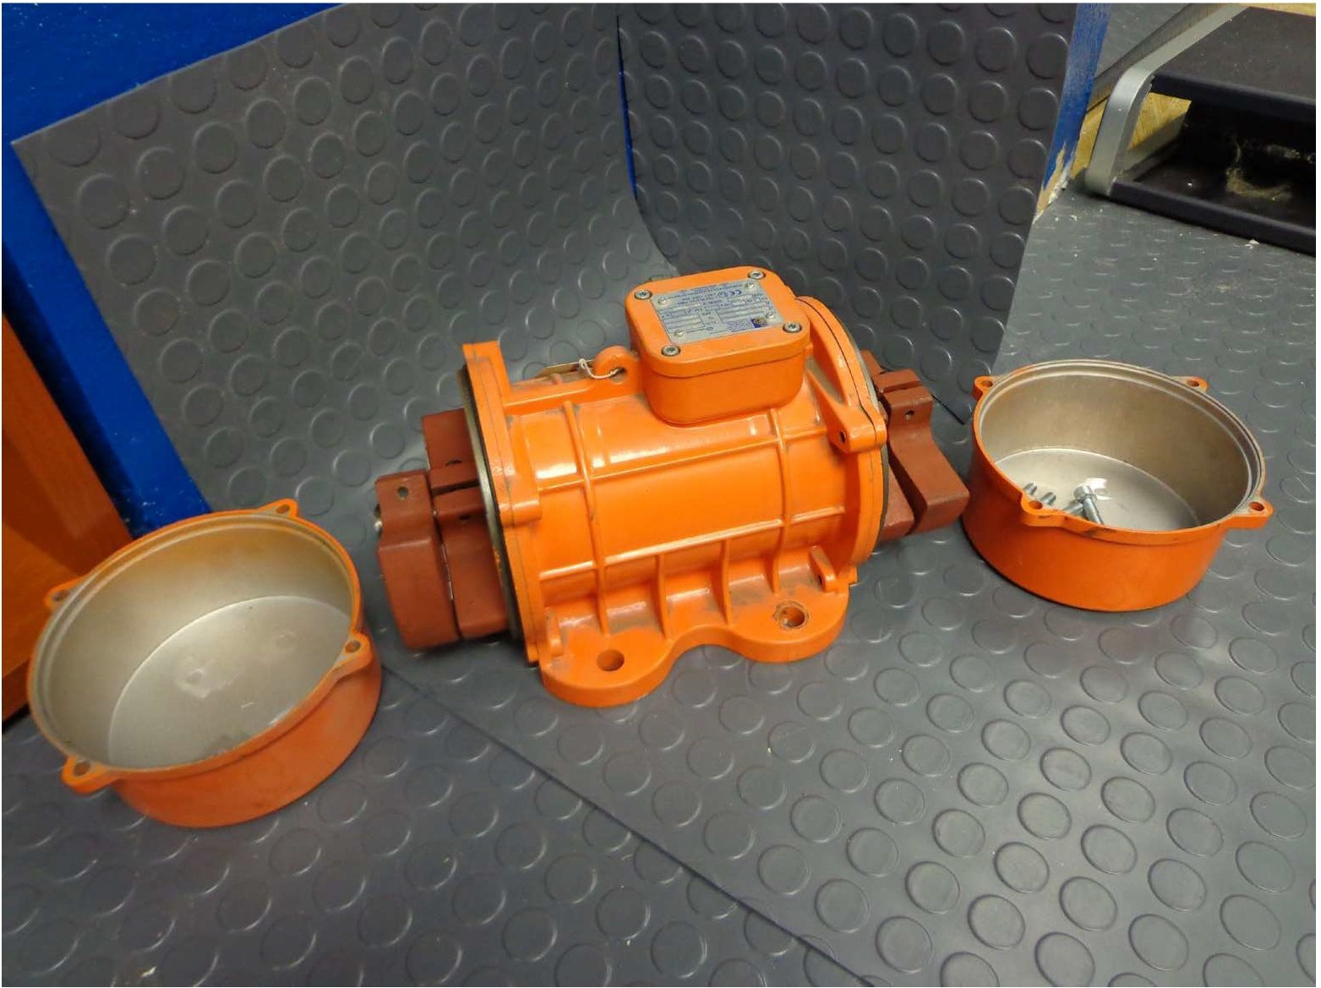
This is the Gyrator with both end caps removed.
Remember to adjust both ends to the exact same weight offset.

- Maintenance
Gyrator Force Adjustment

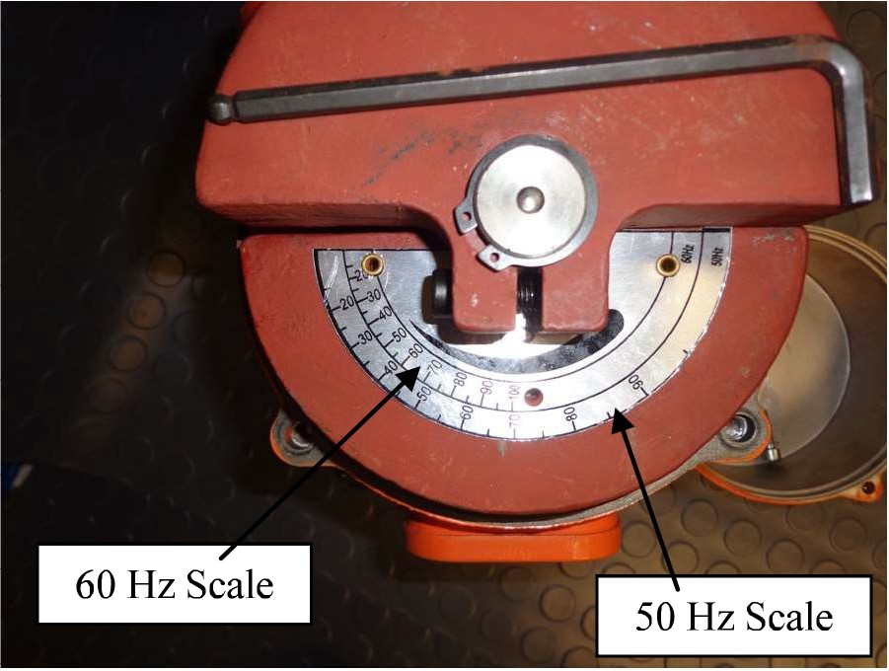
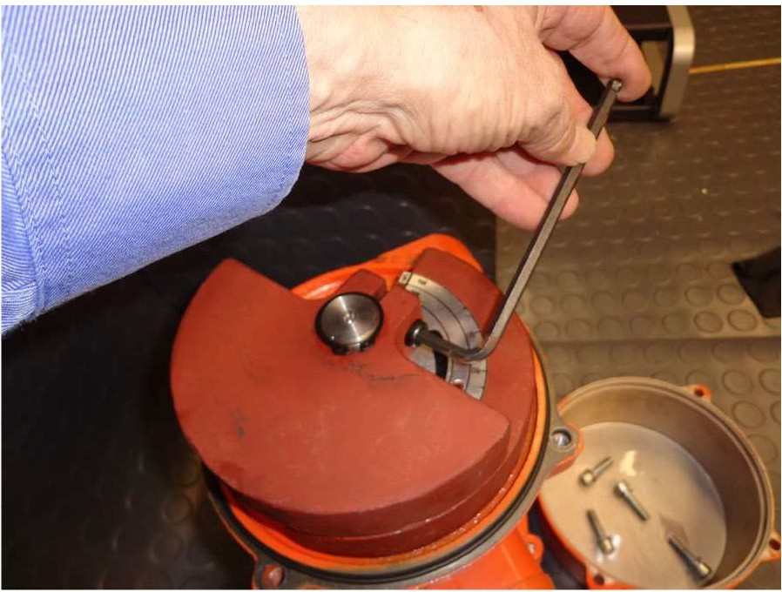
It is critical to adjust the weights on both ends of the gyrator to the exact same force. Failure to do so will cause premature failure of the bearings. Loosen the bolt that holds the counter weight in place, so the weight can be rotated to the correct position.
There are two force scales. One is for 60Hz the other is for 50Hz. Since the gyrator runs slightly slower at 50Hz, more off set weight is required to get the same pound force.
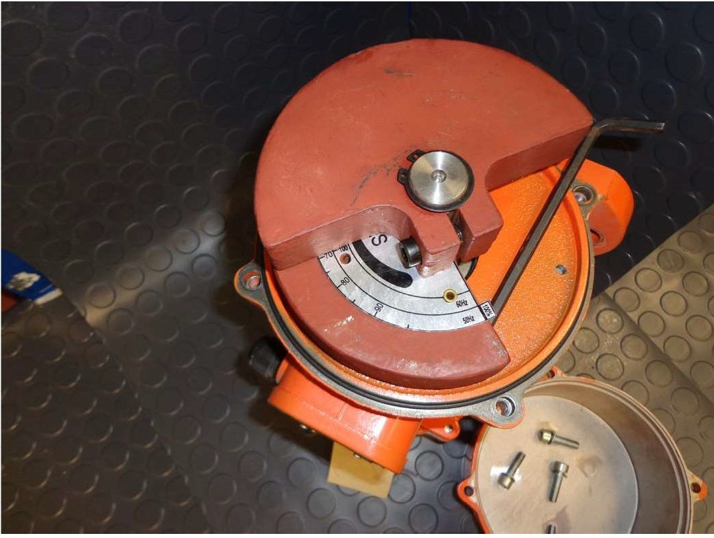
Be sure you are using the correct scale for the voltage frequency. USA customers will always use the 60Hz scale.
This is the position for 100% of the full force from this gyrator when running at 60Hz. Running the gyrator at a higher force setting than this, will cause premature bearing failure. It is recommended that Locktite or some other thread locking compound be used to secure these counterweight bolts. If one comes loose, it will most likely cause a bearing failure.
Once the weights on both ends are adjusted to the same pound force, replace the end caps.

- Maintenance
Fill Spout Seal (Expandable Bladder)
There is an upper clamp on this unit that is visible on the outer pipe of the fill head. This should be loosened first. Once loose the bladder can be pulled out from under the clamp. The bladder should be pulled from the top edge down and inside out – exposing the second (inside) clamp. Once this clamp is loosened the bladder can be removed.

To replace, the bladder should be turned inside out (so that the slick side is out. One end should be pulled up and onto the outer pipe of the fill head approximately 2” – 3”. A clamp should be pulled up and over the bladder and the fill head and tightened. The other end of the bladder should now be pulled up and over that clamped end (turning the bladder inside out). Once pulled slightly taught, the top clamp can be tightened over the top of the bladder. Unit is now ready for air hook up and inflation.

Vibrating Finger Adjustment:
High frequency vibration is used to settle material in the bulk bag as it is filled. In order to maximize the energy transmitted to the bulk bag and minimize the energy applied to the machine, the pallet the bulk bag sits on, is lifted off the rollers slightly, when the vibrator is running. There is a large, short stroke air cylinder on each corner of the filling machine which lifts metal fingers through the slits between the rollers to lift the pallet off the rollers. If these cylinders lift too far, the vibrating structure will contact the bottom of the rollers. This can make a horrendous noise, and will damage the machine quickly if not corrected. Since rather precise positioning of these cylinders is required, each one has its own lift height adjustment.

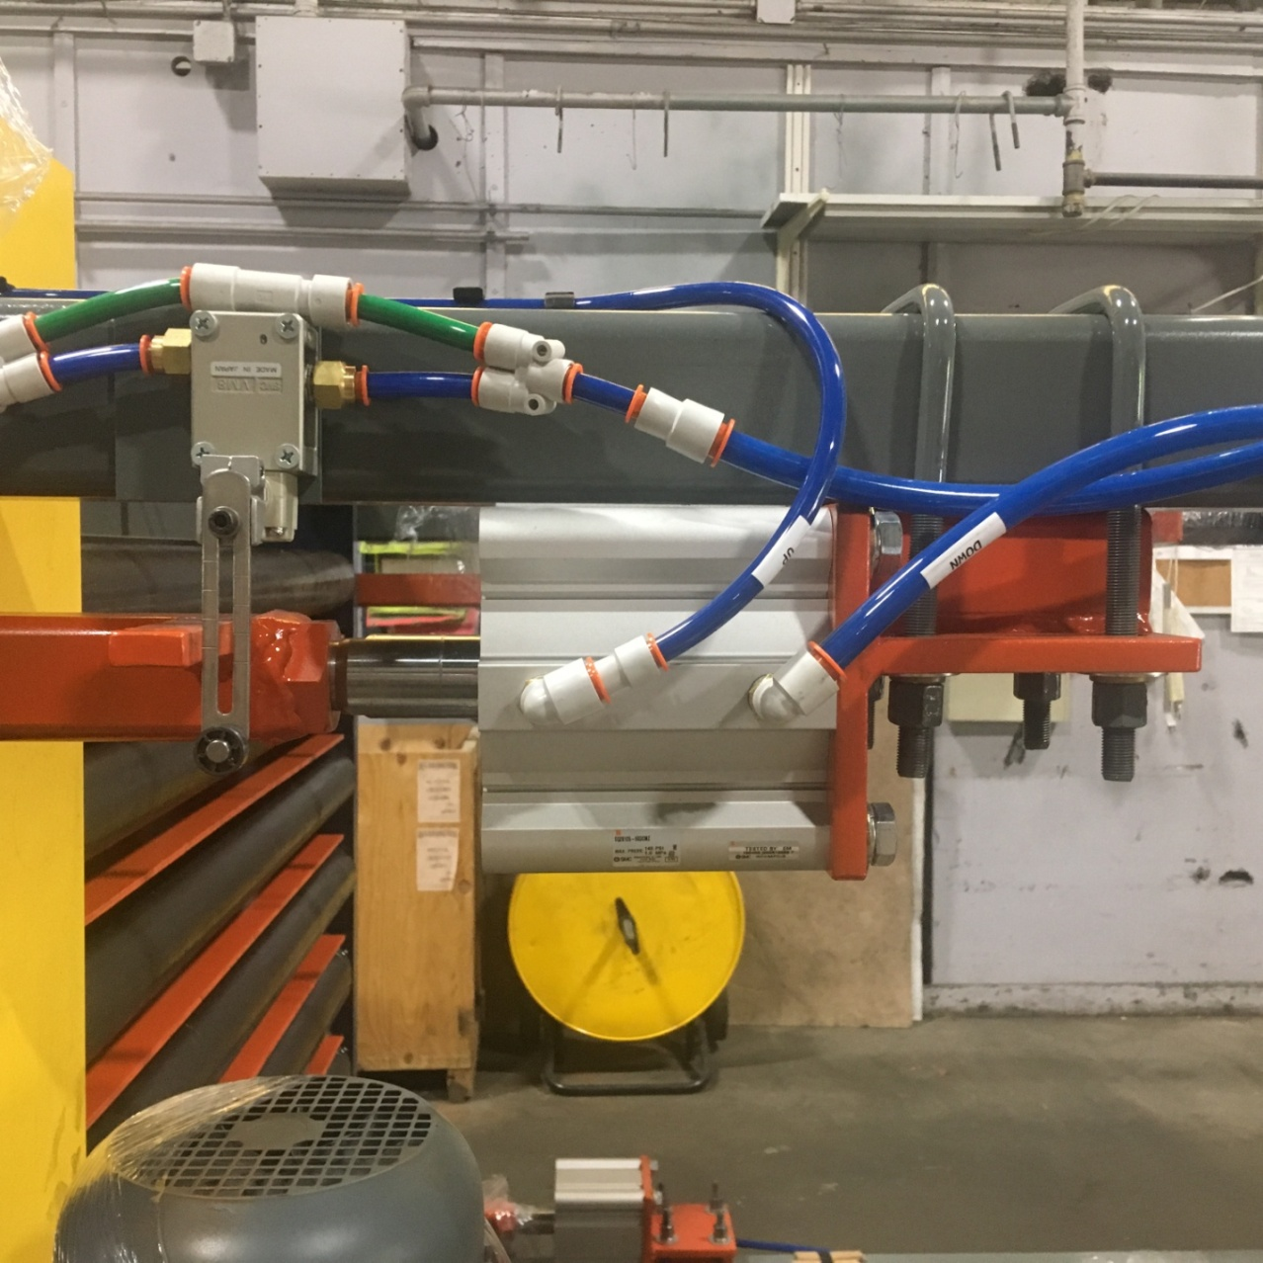
Impact Bar
Air Switch
Air Cylinder
Position Lever
Lock screw, loosen to adjust lever.
Check Valve
Impact bar
Air switch
- Maintenance
Vibrating Finger Adjustment (Cont.)
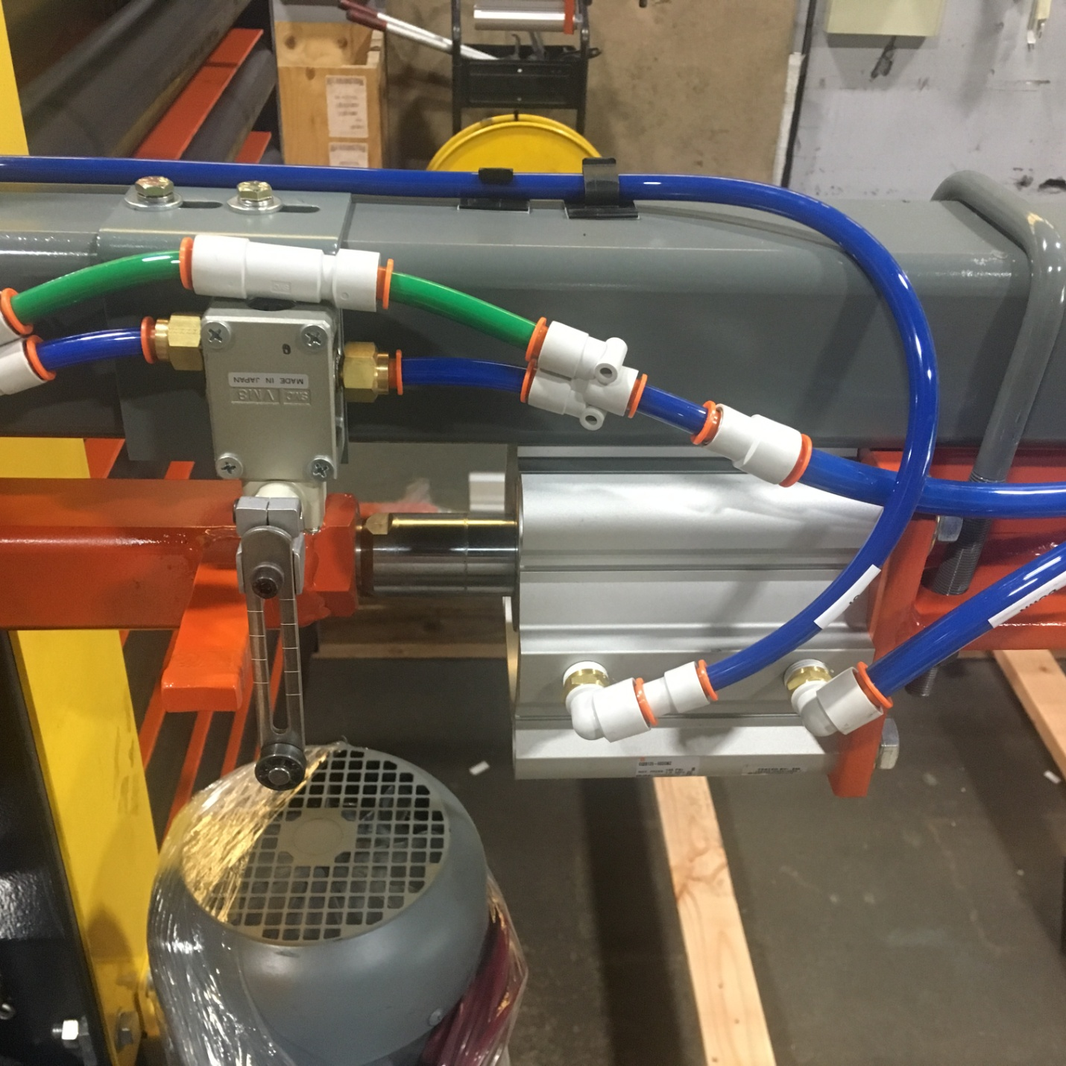
Fingers between rollers. They only lift the bag 1/4".
Fingers lift lower when lever is moved down.
Fingers lift higher when lever is moved up.

The fingers only protrude enough to lift the lift the pallet off the rollers. If it lifts too much, it will press against the bottom of the rollers, and is very noisy. The machine will be damaged if this is not corrected. The vibrator is not quiet, but if it's really loud, check this adjustment on each leg.

The system compensates for the weight in the bag, and will lift the bag to the same position at any point in the fill cycle.

- Maintenance
Adjusting the air pressure on the Inflation Boot:

The air pressure on an inflation boot should not be adjusted higher than 5 psi. However, using the gage to set the pressure is not the best way.

To get the best life from the inflation boot, and reduce the chance of damaging a bulk bag fill spout, only inflate the boot enough to securely hold the bag on the machine spout. The best way to find that point is to open the regulator until the pressure in the line is zero. Pull the bulk bag spout up and over the inflation boot. Turn the hand valve to the inflate position, and begin to add pressure by turning the regulator knob. As soon as the fabric has stretched, completely, stop adding pressure. Tug firmly on the spout, to be sure it’s locked on, then proceed to fill the bags.

If the regulator pressure is set too high, the seam on the bag fill spout will start to rip. Turn the regulator pressure down, if you head the seam ripping.
Fill Head Booting:
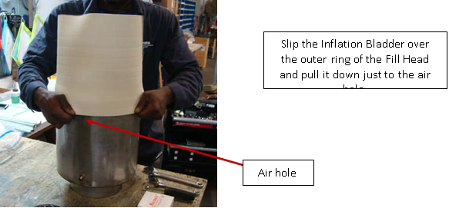
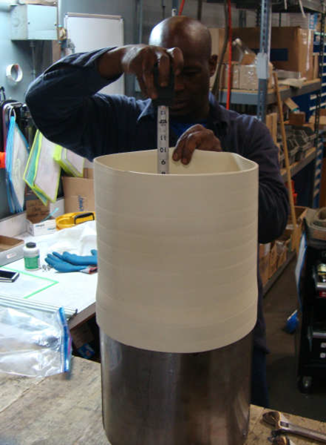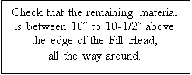
- Maintenance
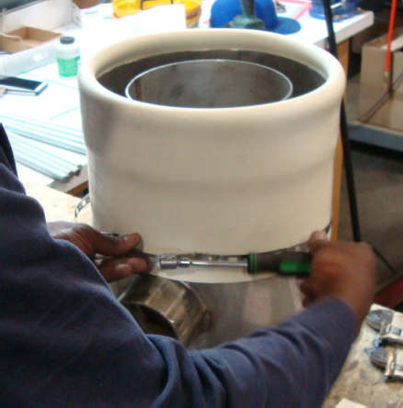
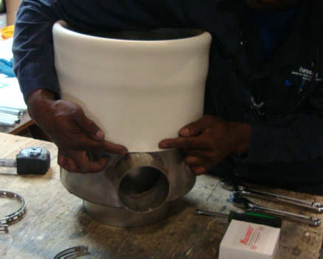
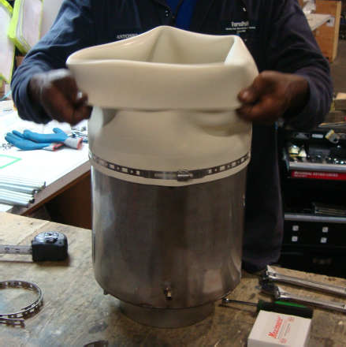
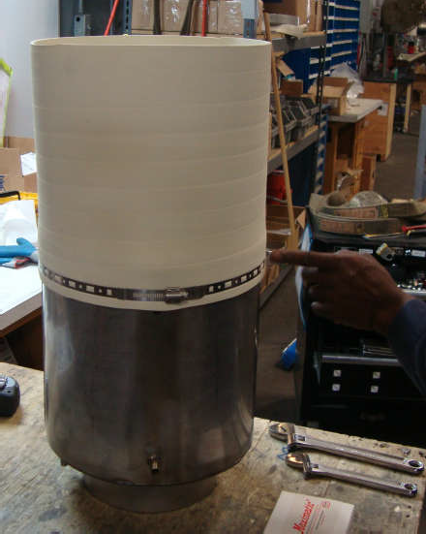
Fill Head Booting (Cont.)
Once the boot is in position, use and tighten the banding clamp
to secure the boot in place.
Tighten as hard as possible without breaking the clamp.
Continue to pull the boot down onto the Fill Head until just at the dust port
Next, fold over the boot to the outside and pull it down over the already clamped area.
Once the boot is in position, use and tighten the banding clamp
to secure the boot in place.
Tighten as hard as possible without breaking the clamp.
Formpak Machinery Catalog

BagPak Series (Bulk Bag Fillers)
- BagPak 1100-DT (Duffel Top Bag Filler)
- BagPak 2100-ST (Spout Top Bag Filler)
- BagPak 2100-SS (Spout Top, Scale Controlled Bag Filler)
- BagPak 4400-AD (Auto Discharge Bag Filler)

BagFlo/EasyFlo Series (Bulk Bag Dischargers)
- BagFlo 500-FL (Fork Loaded Bulk Bag Unloader)
- BagFlo 500-HT (Hoist & Trolley Loaded Bulk Bag Unloader)
- BagFlo 500-HF (Half Frame Bulk Bag Unloader)
- BagFlo 500-RK (Retrofit Kit)
- EasyFlo 500-FL (Free Flowing Bulk Bag Unloader)
- EasyFlo 500-HT (Free Flowing Bulk Bag Unloader)
- EasyFlo 500-HF
- BagFlo LIW (Loss-in-Weight Bulk Bag Unloader)
- BagFlo GC (Gantry Crane Bulk Bag Unloader)
- BagFlo SLH (Super Low Head)

Lifting Devices
- BagLift 100-CA (Bulk Bag Crane Adapter)
- BagLift 100-FA (Bulk Bag Fork Adapter)
- BagLift 100-FF (Flying Fork Adapter)
- BagLift 100-LH (Low Head)
- BagLift 200-HL (High Lift)

Small Bag Handling Equipment (Bag Break Stations)
- BagBreak 100-SH (Simple Bag Break Hopper)
- BagBreak 400-UC (Bag Break with Upper Cabinet)
- BagBreak 400-DF (Dual Filter Bag Break)

Other Products
- FlexFlo Flexible Screw Conveyors
- FeedFlo-VSF (Volumetric Screw Feeder)
- FeedFlo-VFV (Vibratory Volumetric Feeder)
- FeedFlo-SFS (Screw Feeder with Scale)
- FeedFlo-VFS (Vibratory Feeder with Scale
- FeedFlo LIW (Loss-In-Weight) feeder
- GH-1000 (Gyrated Hopper)
- VM-4000 (Venturi Mixing System)
- MatFlo (Lump Breaker)
- BagBreaker (Bag Conditioner)
- Live Hoppers
- Eduction Systems
- Batching Systems

