FORMPAK INC

The IOM covers the following:
- 1100 DT
- 1100 DT IS
- 1100 DT PS
- 1100 DT DD
- 1100 DT IH

1100 DT Series IOM
2021 eDITION

DISCLAIMERS:

NOT ALL ITEMS IN THIS MANUAL ARE ON EVERY SYSTEM.

SYSTEM CONFIGURATIONS VARY PER CUSTOMER ORDERS & SPECS.

ANY MODIFICATIONS TO THE EQUIPMENT WITHOUT APPROVAL OF FORMPAK ENGINEERING WILL RESULT IN VOIDING ANY WARRANTY.

Operation Hours

Monday – Friday 8:00AM-5:00PM CST

Contacts at FormPak

Mike Owens Ext 402
Sales / General Questions Email: mike@formpakinc.com

Larry Markos, P.E. Ext 403
Engineering / Technical Support / Maintenance Email: larry@formpakinc.com

Robert Contreras Ext 405 Operations Manager Email:
Email: robert@formpakinc.com

Joseph Beckerman Ext 414
Electrical / Controls Email:
Email: josephb@formpakinc.com

Brian Beirne Ext 412
Purchasing / Parts Email:
Email: brianb@formpakinc.com

Fax: 314-475-3201

1100 DT SERIES INDEX
Section Page
- Introduction (4)
- Pre-Inspection/Unit Arrival (5)
- Hardware list (5)
- Unpacking Instructions (5)
- Installation (6-7)
- Operation (8)
- Maintenance (8)
- Replacement Parts List (8)
- Optional Enhancements (9-11)
- Formpak Machinery Catalog (12)

- Introduction
Our Duffel Top Bulk Bag filling rack, BagPak 1100-DT, is designed for easy filling of full open and/or duffel top big bags with lift loops. The bulk bag loops are fed onto the holder arms which are adjusted to the correct height for proper filling. Once full the Bulk Bag is removed via pallet by forklift (lifting up and backing out). Wide base or Spread base for pallet jack access is also available. Two (2) standard frames are in stock, but other size ranges available. Units are easily transported via fork pocket base. Construction is heavy gauge structural steel coated in enamel paint.
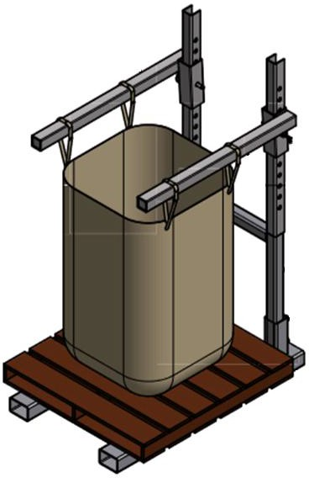

II. Unit Arrival
- Hardware list
- Frame base
- Frame upright
- Bag holder arms (2)
- Securing bolts (4)
- Fill head adjustment bolt
- Arms hitch pins (2)

- Unpacking Instructions
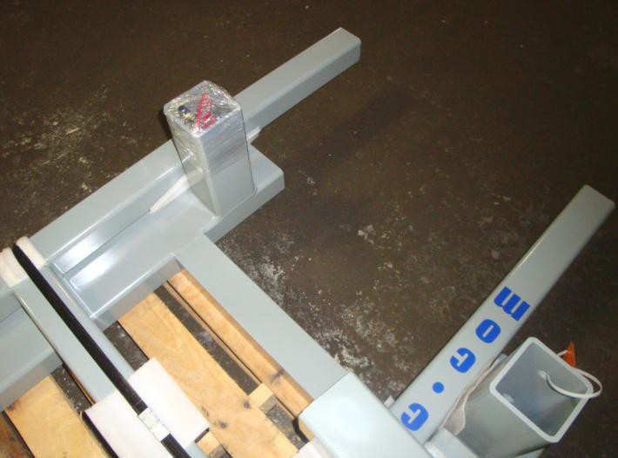
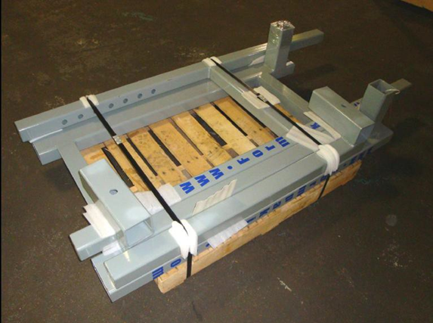

The frame upright securing bolts and the bag holder arms hitch pins are located inside one of the frame base upright post holes (as shown below) or in a box of hardware attached to your shipment. Carefully cut and un-strap the unit from the skid for assembly. Remove the bolts and hitch pins from the upright post hole (do not discard).and un-strap the unit from the skid for assembly. Remove the bolts and hitch pins from the upright post hole (do not discard).

The BagPak 1100-DT unit comes packaged as shown.

III. Installation

FOR SAFETY, it is best to have at least 2 qualified people working on the assembly of this unit.
National, state, and local safety codes must be adhered to.

Failure to follow the steps could result in injury or death.

Assembly of your BagPak-1100-DT Frame

Video Link: https://youtu.be/iWjGsrKJRDQ
- Place the frame base on a flat surface, slide the upright section into the frame base post holes and thread (4) securing bolts into the threaded extensions (see Figure 1).
- Firmly and securely tighten the securing bolts to hold the frame upright in place. These bolts should be checked regularly (and re-tightened if needed) to maintain unit stability and safety.
- Once the frame upright is secure, the bag holder arms can be added to the unit. Position the bag holder arm to the outside of the frame upright as the sleeve slides over the upright post. Then place a hitch pin through the alignment positioning holes. Repeat for the other arm.
- The final bag holder arm height position is determined by your bag height. Place a skid onto the frame base and hang an empty bag on the holder arms. The holder arms should then be adjusted to a height that allows for the pallet on the base, the bag hung by the loops and leaves 2” – 3” of clearance on the corners of the bag above the pallet. This will allow proper filling of the bag (See Figure 2).
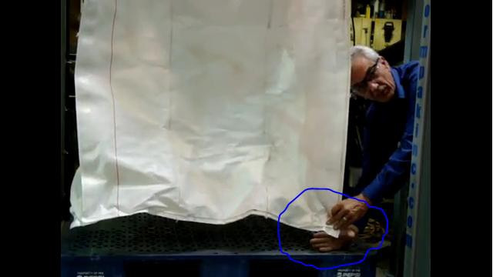
- Insert the hitch pin safety pins to capture and hold the hitch pin in place during operation
III. Installation

FINAL SAFETY STEP PRIOR TO ANY ACTUAL BAG FILLING OPERATION

The hitch pins safety pin MUST be inserted to capture and hold the hitch pin in place during operation.
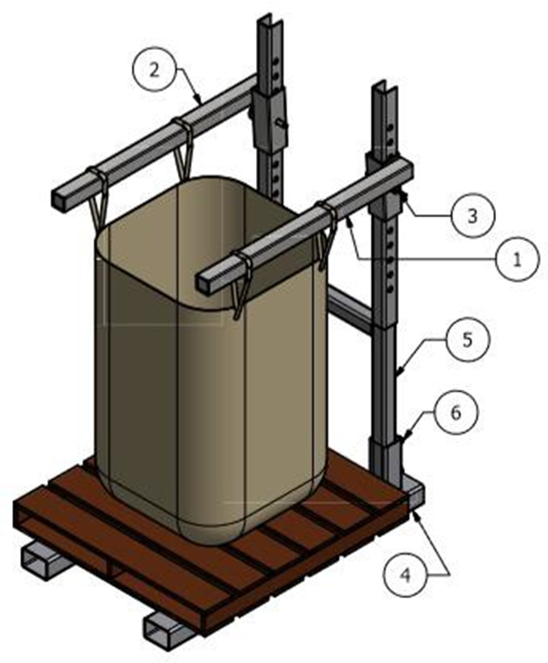
(Figure 1: Picture shown is for reference only; the frame base may be different)
1. Left hand side 2. Right hand side 3. Hitchpin with Hairpin Clip 4. Lower Frame 5. BagPak 1100
Upper Frame 6. Hex Bolt

IV. Operation
Operator places pallet onto the base and bag straps are fed over holder arms. Bag is now ready for filling. Once filled, bag can now be lifted via fork lift (pallet) and removed from machine.
V. Maintenance
A weekly check of the framework, securing bolts and hitch pins for proper installation, tightness and safety is recommended to keep the equipment in proper working order.
VI. Replacement Parts List
* Not all of these parts below are on every unit *

- - Contact us for current lead time - -

1100 Parts Lists
Description | Material | Formpak Number | Quantity | Price/ea. | Total
Load Cell Foot Plate | Steel, Mild | 000014 | 2 | $58.00 | $116.00
Rice Lake Load Cells | Stainless Steel, 304 | 001373 | 2 | $495.00 | $990.00
Load Cell Foot/Adjuster | Stainless Steel, 304 | 000013 | 2 | $55.00 | $110.00
Summoning Box | Stainless Steel, 304 | 000015 | 1 | $162.50 | $292.50
Vibration Motor (Electric) | Steel, Alloy | 000004 | 1 | $623.50 | $623.50
Isolator | Rubber | 000030 | 1 | $50.19 | $75.29
Hitch Pins | Steel, Alloy | 000548 | 2 | $6.00 | $12.00
 |  |  |  | Grand Total: | $2,219.29

VII. Optional Enhancements
Enhancement | Model | Reference | Overview
Load Cells | 1100-DT- IS | 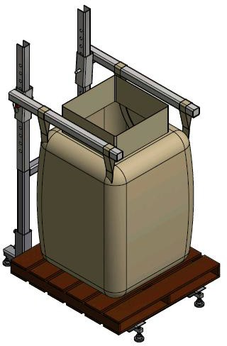 | These are typically bolted into the frame and can be unbolted for removal. The scale wire associated with that load cell will need to be disconnected from the summing box. A new load cell can be bolted back into place, the nesting foot screwed back into place, and the control wire pulled back into the summing box and connected to the requisite terminals.
Casters |  | 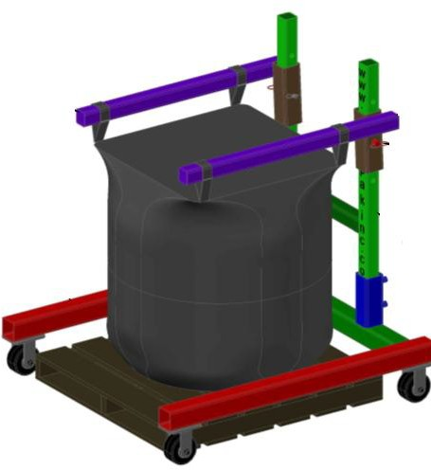 | For easy mobility  (4) casters can be added to the frame. These are typically arranged as (2) fixed and (2) swivel casters, all locking
VII. Optional Enhancements
Platform Scale | 1100-DT- PS | 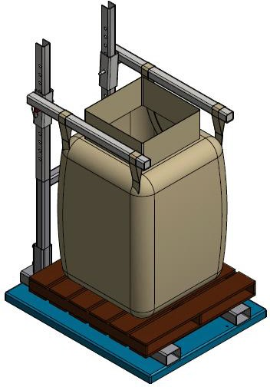 | A 5' x 5' or 4' x 5',  5,000# capacity floor scale with bag frame bolted to the top. Scale is pre- wired to a digital indicator.
Powered Indexing Arms |  | 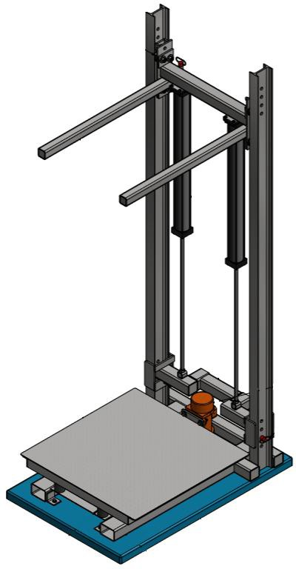 | Typically used when bags are very tall to facilitate easy attachment to filler, but can also be set up for a (2) bag size arrangement. Rear supports are I- beam construction and holder arm assembly is riding on bearings driven by air cylinders.

VII. Optional Enhancements
Densification Deck | 1100-DT- DD | 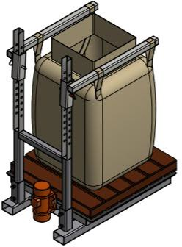 | By flex connecting a 48” x 48” diamond plate (reinforced) deck to (4) isolators and mounting a 1,500# force, 1HP dual shafted gyrator, the bag can be densified via high frequency vibration. This is typically done intermittently during fill cycle
Integrated Hopper | 1100-DT- IH | 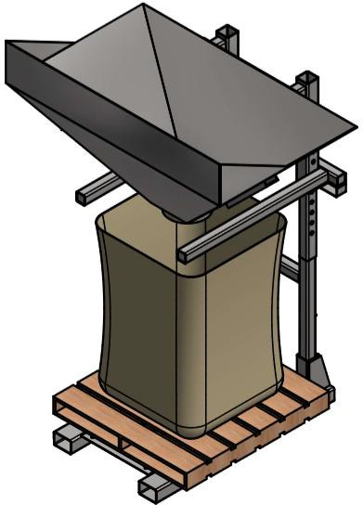

VIII. Formpak Machinery Catalog

BagPak Series (Bulk Bag Fillers)
- BagPak 1100-DT (Duffel Top Bag Filler)
- BagPak 2100-ST (Spout Top Bag Filler)
- BagPak 2100-SS (Spout Top, Scale Controlled Bag Filler)
- BagPak 4400-AD (Auto Discharge Bag Filler)

BagFlo/EasyFlo Series (Bulk Bag Dischargers)
- BagFlo 500-FL (Fork Loaded Bulk Bag Unloader)
- BagFlo 500-HT (Hoist & Trolley Loaded Bulk Bag Unloader)
- BagFlo 500-HF (Half Frame Bulk Bag Unloader)
- BagFlo 500-RK (Retrofit Kit)
- EasyFlo 500-FL (Free Flowing Bulk Bag Unloader)
- EasyFlo 500-HT (Free Flowing Bulk Bag Unloader)
- EasyFlo 500-HF
- BagFlo LIW (Loss-in-Weight Bulk Bag Unloader)
- BagFlo GC (Gantry Crane Bulk Bag Unloader)
- BagFlo SLH (Super Low Head)

Lifting Devices
- BagLift 100-CA (Bulk Bag Crane Adapter)
- BagLift 100-FA (Bulk Bag Fork Adapter)
- BagLift 100-FF (Flying Fork Adapter)
- BagLift 100-LH (Low Head)
- BagLift 200-HL (High Lift)

Small Bag Handling Equipment (Bag Break Stations)
- BagBreak 100-SH (Simple Bag Break Hopper)
- BagBreak 400-UC (Bag Break with Upper Cabinet)
- BagBreak 400-DF (Dual Filter Bag Break)

Other Products
- FlexFlo Flexible Screw Conveyors
- FeedFlo-VSF (Volumetric Screw Feeder)
- FeedFlo-VFV (Vibratory Volumetric Feeder)
- FeedFlo-SFS (Screw Feeder with Scale)
- FeedFlo-VFS (Vibratory Feeder with Scale
- FeedFlo LIW (Loss-In-Weight) feeder
- GH-1000 (Gyrated Hopper)
- VM-4000 (Venturi Mixing System)
- MatFlo (Lump Breaker)
- BagBreaker (Bag Conditioner)
- Live Hoppers
- Eduction Systems
- Batching Systems

